Fort Worth Public Library, Central: Library Profile

Lindsay Robbins

INFO 5400.001

09-18-22

Citation Format: APA

1. **General Information** 
   1. Background Information
      1. The Fort Worth Public Library is a system consisting of sixteen locations—their Central location is located in downtown Fort Worth, at 500 W. 3rd Street Fort Worth, TX 76102. This institution is a public library with a deep-rooted history in the city, first established in 1892 by a group of women organized by Jennie Scheuber, who persuaded Andrew Carnegie and other donors to contribute funds for the building and its operations (City of Fort Worth, 2022a). The library officially opened in 1901 and has since expanded to a large system housing over 2 million materials (City of Fort Worth, 2022a). The library originally opened as the Carnegie Public Library of Fort Worth, in a building that has since been demolished (Moore, 2015). The new Central library opened 1978 (Moore, 2015). The library soon began expansion in 1992 (City of Fort Worth, 2022b), supported by the Fort Worth Public Library Foundation—founded in 1993 (City of Fort Worth, 2022c). Expansions on the exterior were completed in 1995, and within the next several years, the interior was also expanded (City of Fort Worth, 2022d; 2022e). Notably, as of 2022, the Central library physical location is to be sold, and the library is to downsize from its current 234,000 square foot building to a much smaller one (Mantas, 2022).
   2. Service Area
      1. The service area of the Central location is reflected by its physical location in downtown Fort Worth. Users must have a library card to access the collections, and the issuance of these cards differs depending on the status of those who apply. In order to be issued a resident card, the user must provide basic demographic information as well as proof of residency, as the library is a public, local institution (City of Fort Worth, 2022g). There are alternatives for those who cannot provide proof of residency, however, such as a non-resident card which can be purchased for a $50 yearly fee (City of Fort Worth, 2022g). This allows users to access to both physical and online materials, as well as many other features of the library (City of Fort Worth, 2022g). Other special circumstances include those who are students, employees of the city of Forth Worth, educators, organizations, or those holding a card from a participating TexShare institution (City of Fort Worth, 2022g).
   3. Intended Audience/Target Population
      1. As a public institution, the library’s intended audience is wide in scope. This is supported by their broad mission and values statements, which emphasize learning, individual growth and community (Fort Worth Public Library, 2018). The primary users of the library are those in the community of Fort Worth, primarily residents. See Appendix A. for U.S. Census data for the city of Fort Worth. As of the 2021 Texas Public Libraries Annual Report, the total population of the legal service area for the Central location is 918,915 (Texas State Library and Archives Commission, 2021). The library’s programming and attendance suggest that users from a wide variety of demographics use the library’s services. As indicated in the Texas Public Libraries Annual Report 2021 report, they provided a large number of synchronous programs for all age-groups, however the attendance numbers for programs targeted at adults is significantly higher than that of any of targeted age group, especially that of young adults which is significantly lower than the others (Texas Public Libraries Annual Report, 2021). The local area surrounding the library’s physical location is crowded and very urban, with restaurants, museums and other public businesses on all sides. As there is limited parking, many patrons may come on foot or through local transit. The Fort Worth Central Station is only a short walk from the library, a station that provides transportation through commuter rail, taxi, bus and train services (Trinity Railway Express, 2019). There are also several elementary and higher education institutions nearby. According to library patron mapping, of the over 200,000 visits to the Central location in 2018, many came from “across the city” (Fort Worth Public Library, 2020a).
2. **Funding** 
   1. Sources of funding
      1. According to the 2021 Texas Public Libraries Annual Report, the library receives a fairly large amount of grant operating revenue, however in comparison to their overall operations cost, this is a very small fraction (Texas State Library and Archives Commission, 2021). A small portion is also received from federal sources, but the biggest portions received are from the city and local government (Texas State Library and Archives Commission, 2021). Financial support is also provided to the institution through the Fort Worth Public Library Foundation, a 501(c)(3) charity organization that aids the system through fundraisers (Fort Worth Public Library Foundation, 2022). Historically, they have raised over 19 million dollars for the system (Fort Worth Public Library Foundation, 2022). See Appendix B. for detailed budget data.
   2. Budget
      1. According to the 2021 Texas Public Libraries Annual Report, the Central location had a relatively high operation cost overall compared to many of the other institutions reporting for that year with a total of $21,478,194 in operating expenditures (Fort Worth Public Library Foundation, 2022). Largely, the electronic materials cost was much higher than that of print—a $2,203,400 total versus $761,119 [See Table 3].
   3. Budget History
      1. The budget for the library appears to have been steadily increasing over time. This can be evidenced in prior city budgets. In 2010, the city budget for the library was $17,435,414 (City of Fort Worth, 2010). As of the 2022 adopted city budget, the adopted budget for the library was 22,295,293—overall, a several million dollar increase in a little over a decade (City of Fort Worth, 2021).
3. **Collections** 
   1. Overview
      1. The Central facility of the Fort Worth Public Library is housed in a large building with many collection materials on a lower floor as well as smaller side rooms. The size of the collection is large, with a total of 1,169,165 items consisting of downloadable content such as videos and audio as well as many physical books, audio, video and miscellaneous objects [See Table 9] (Texas State Library and Archives Commission, 2021).
   2. Formats collected
      1. The Fort Worth Public Library has a large variety of formats available including, physical books, eBooks, physical movies, video games, audiobooks, eaudiobooks, and other digital content (Fort Worth Public Library, 2022). Some digital materials can be accessed at the physical location, and many can be accessed off-site after providing user login information (Fort Worth Public Library, 2022). This library utilizes the widely popular Overdrive application to provide digital content as well.
   3. Collection arrangement
      1. According to the 2019 Facility Plan, the building that the library is housed in is nearly 250,000 square feet, however the library “occupies less than 120,000 square feet”, half of which is the basement level, in which the Genealogy History & Archives are located (Fort Worth Public Library, 2020a). The entire upper floor, as well as many other areas are still unfinished, though it also is where “more than 40% of the system’s collection is located” (Fort Worth Public Library, 2020a). The library utilizes the Dewey Decimal system in physical organization, but objects are also arranged by interest or new/relevant content, as certain curated collections such as the timely collection on Queen Elizabeth II demonstrate (Fort Worth Public Library, 2022).
   4. Items excluded
      1. No specific items are automatically excluded, according to the Collection Development Policy, however the library does not necessarily add all donation items to the collection (Fort Worth Public Library, 2020b).
   5. Collection Strengths and Weaknesses
      1. One major strength of the collection is the variety and offerings available in the Spanish language. Additionally, this is supported by ESL programming that is largely positively perceived (Bodine & Francis, 2022). The major weakness of the collection is its current housing situation in the largely empty building it now occupies. As communicated in an article for the Fort Worth Report, there are mixed feelings about the location of the Central branch being moved, however there are those that view it as progress (Bodine & Francis, 2022).
4. **Collection Development** 
   1. Who Develops the Collection
      1. Per Kathryn King, current manager of Collection Development, “FWPL has centralized selection. A staff of 4 work in collection development. When we select, we look at the system as a whole but buy for each individual location taking into account their unique demographics, programming, etc.” (K. King, personal communication, September 19, 2022).
   2. How the Collection is Developed
      1. The collection is developed based on the current Collection Development Policy, which is a detailed outline of considerations “regarding the selection, management, and preservation of the collection” (Fort Worth Public Library, 2020b). A list of considerations for each material include content, cost, critical reviews, current and anticipated appeal, format, local interest, relation to the existing collection, relation to other resources in the community, significance of the author/creator or publisher, suitability of subject and style for intended audience, support of library programs and initiatives, and timeliness (Fort Worth Public Library, 2020b). Additionally, there are special considerations for the format of materials when they are digital in nature. These include “Accessibility; Ease of use; Equipment, training, and technology requirements; License agreement requirements and vendor support; [and] Unique content”. (Fort Worth Public Library, 2020b). The collection development policy also outlines guidelines for removal or disposal of materials, suggestions for purchase and reconsideration. If residents wish to request a purchase for the library, they may do so in person or through an online form (Fort Worth Public Library, 2020b). When considering which materials to remove, staff reviews data on circulation rates, “collection turnover rates, collection age, and demographic changes” in the service area (Fort Worth Public Library, 2020b). “FWPL adds just over 14,000 unique book titles each year”, purchased from a variety of vendors (K. King, personal communication, September 19, 2022). See Table 18 for detailed vendor information.
5. **Library Services (2 points)**
   1. Basic Services
      1. Computers are available for users as well as Wi-Fi, printing, laptop loans, and iPad rental (City of Fort Worth, 2022i). Printing services are also available, which can be utilized through mobile devices as well (City of Fort Worth, 2022i). In 2020, the library closed temporarily due to COVID-19, and the library responded by implementing new procedures such as curbside delivery and purchasing PPE equipment as well as limited in-person services such as in-person checkouts and computer access (Gorman, M., 2020). As of February 2022, the lower levels remain closed off since they were initially closed at the beginning of the pandemic (Mantas, 2022). The library still provides curbside pickup and digital services for those who would prefer no contact (City of Fort Worth, 2022i).
   2. Programming
      1. As noted in section IA, the library provides user education and courses for all ages. The Central location in particular is able to provide live musical entertainment utilizing their theater and lecture facilities (City of Fort Worth, 2022f). Classes range from story time for children, to computer skill courses for adults (City of Fort Worth, 2022f). There is a wide variety of courses including an English as a Second Language (ESL) course for adults, high school equivalency programs, homework assistance, literacy and more (City of Fort Worth, 2022l).
   3. User Education
      1. There are many offerings in user education that aid in utilizing the resources at the library. Many of these are centered on technology literacy such as the basic computer skills courses and internet basics courses (City of Fort Worth, 2022l).
   4. Other Offerings
      1. The Central Library location contains fixtures such as the “Bumpersaurus slide”, an interactive sculpture by artist Allen Boerger, which is a large dinosaur-shaped slide that children can play with (City of Fort Worth, 2022k). There are also art displays housed in the east and west galleries on site (City of Fort Worth, 2022f). Additional offerings from the institution include baby bags, bilingual baby bags, STEAM kits, kid’s robot kits, musical instruments and more (K. King, personal communication, September 19, 2022).
6. **Existing Policies**
   1. The policies for the Fort Worth Public Library apply to all branches and include the following: After Hours Meeting Room Rental, Behavior Policy, Behavior Incident Appeal Process, Child Safety Policy, Circulation Policy, Collection Development Policy, Co-Sponsorship of Community Programs Policy, Distribution of Nonlibrary Materials, Early Literacy iPad Loan Agreement, Exhibitor Policy, Laptop Loan Agreement, Meeting Room Use Policy, Mobile Wi-Fi Hotspot, Naming/Recognition Policy, Open Access Policy, Privacy and Confidentiality Policy, Public PC, Internet and Wireless Use Policy, and an Internet Notice and Disclaimer (City of Fort Worth, 2022i).
7. **Documentation & Appendices**

**Works Cited**

Bodine, S., & Francis, B. (2022, March 21). Book it: Here’s why Fort Worth’s Central Library is for sale. *Fort Worth Report*. https://fortworthreport.org/2022/03/21/book-it-heres-why-fort-worths-central-library-is-for-sale/

City of Fort Worth. (2010). *FY2010 Budget*. https://www.fortworthtexas.gov/files/assets/public/planning-data-analytics/documents/budget-analysis/fy2010-budget/fy2010_budget_adopted.pdf

City of Fort Worth. (2021). *General Fund FY2021 Year-to-Date Budget-to-Actual Revenues and Expenditures*. https://www.fortworthtexas.gov/files/assets/public/planning-data-analytics/documents/budget-analysis/fy2022-budget/22-004-budget-actuals.pdf

City of Fort Worth. (2022a). *Library history*; *Section 1*. https://www.fortworthtexas.gov/departments/library/policy/library-history#section-1

City of Fort Worth. (2022b). *Library history*; *Section 23.*

https://www.fortworthtexas.gov/departments/library/policy/library-history#section-23

City of Fort Worth. (2022c). *Library history*; *Section 24.*

https://www.fortworthtexas.gov/departments/library/policy/library-history#section-24

City of Fort Worth. (2022d). *Library history*; *Section 26.*

https://www.fortworthtexas.gov/departments/library/policy/library-history#section-26

City of Fort Worth. (2022e). *Library history*; *Section 29.*

https://www.fortworthtexas.gov/departments/library/policy/library-history#section-29

City of Fort Worth. (2022f). *Central library*. https://www.fortworthtexas.gov/departments/library/branches/central

City of Fort Worth. (2022g). *Get your library card*. https://www.fortworthtexas.gov/departments/library/services/resident-library-card

City of Fort Worth. (2022i) *Library policies*. https://www.fortworthtexas.gov/departments/library/policy

City of Fort Worth. (2022j) *Mobile-printing*. https://www.fortworthtexas.gov/departments/library/services/mobile-printing

City of Fort Worth. (2022k) *Bumpersaurus slide*. https://www.fortworthtexas.gov/departments/library/services/bumpersaurus

City of Fort Worth. (2022l) *Programs & Resources*. https://www.fortworthtexas.gov/departments/library/programs

David M. Schwarz Architects, Inc. (2022). *Fort Worth Central Library*. https://www.dmsas.com/project/fort-worth-central-library/

Fort Worth Public Library. (2018). *Fort Worth Public Library Strategic Services Plan 2019-2021*. https://www.fortworthtexas.gov/files/assets/public/library/documents/library_stratplan_2018.pdf

Fort Worth Public Library. (2020a). *Fort Worth Public Library Facilities Master Plan FINAL REPORT | 12 February 2020*. https://www.fortworthtexas.gov/files/assets/public/library/documents/library_facilityplan_2019.pdf

Fort Worth Public Library. (2020b). *Collection development policy*. https://www.fortworthtexas.gov/files/assets/public/library/documents/policies/collection-development-policy.pdf

Fort Worth Public Library. (2021). *Chapter 7: Libraries*. https://www.fortworthtexas.gov/files/assets/public/planning-data-analytics/documents/comprehensive-planning/2021/final/07-libraries-final.pdf

Fort Worth Public Library. (2022). https://fwpl.polarislibrary.com/polaris/

Fort Worth Public Library Foundation. (2022). *About us*. https://fwlibraryfoundation.org/about-us

Gorman, M. (2020). *Texas Library Journal*. Fort Worth Public Library Foundation. https://fwlibraryfoundation.org/managing-in-times-of-covid-19

Mantas, H. (2022, February 17). Fort Worth’s Central Library hits the market as the city looks to consolidate property. *Fort Worth Star Telegram*. https://www.star-telegram.com/news/local/fort-worth/article258524123.html

Moore, L. (2015, January 15). Public library (demolished) – Fort Worth. *The Living New Deal*. https://livingnewdeal.org/projects/public-library-demolished-fort-worth-tx/

Texas Public Libraries Annual Report. (2021). Texas State Library and Archives Commission. https://www.tsl.texas.gov/ldn/statistics

Trinity Railway Express. (2019). *Fort Worth Central Station*. https://trinityrailwayexpress.org/station/fort-worth-intermodal-transportation-center-itc-station/

**Appendix A: Detailed Demographics**

**Table 1:** Race data from the United States Census Bureau, 2020

https://data.census.gov/cedsci/table?q=Fort%20Worth%20city,%20Texas&tid=DECENNIALPL2020.P1&tp=false

**Table 2:** Age and Sex data from the United States Census Bureau, 2021

https://data.census.gov/cedsci/table?q=Fort%20Worth%20city,%20Texas&tid=ACSST1Y2021.

**Appendix B: Library Budget**

**Table 3:** Budget 1. Texas Public Libraries Annual Report. (2021). Texas State Library and Archives Commission.

**Table 4:** Budget 2. Texas Public Libraries Annual Report. (2021). Texas State Library and Archives Commission.

**Table 5:** Budget 3. Texas Public Libraries Annual Report. (2021). Texas State Library and Archives Commission.

**Appendix C: Library Map**

**Table 6:** First Floor Level Plan. David M. Schwarz Architects, Inc. (2022). *Fort Worth Central Library*.

https://2cajz746q3h41k3jlsgax8tv-wpengine.netdna-ssl.com/wp-content/uploads/1994/07/5300plan1-1553x1200.jpg

**Table 7:** Second Floor Level Plan. David M. Schwarz Architects, Inc. (2022). *Fort Worth Central Library*. https://2cajz746q3h41k3jlsgax8tv-wpengine.netdna-ssl.com/wp-content/uploads/1994/07/5300plan2-1553x1200.jpg

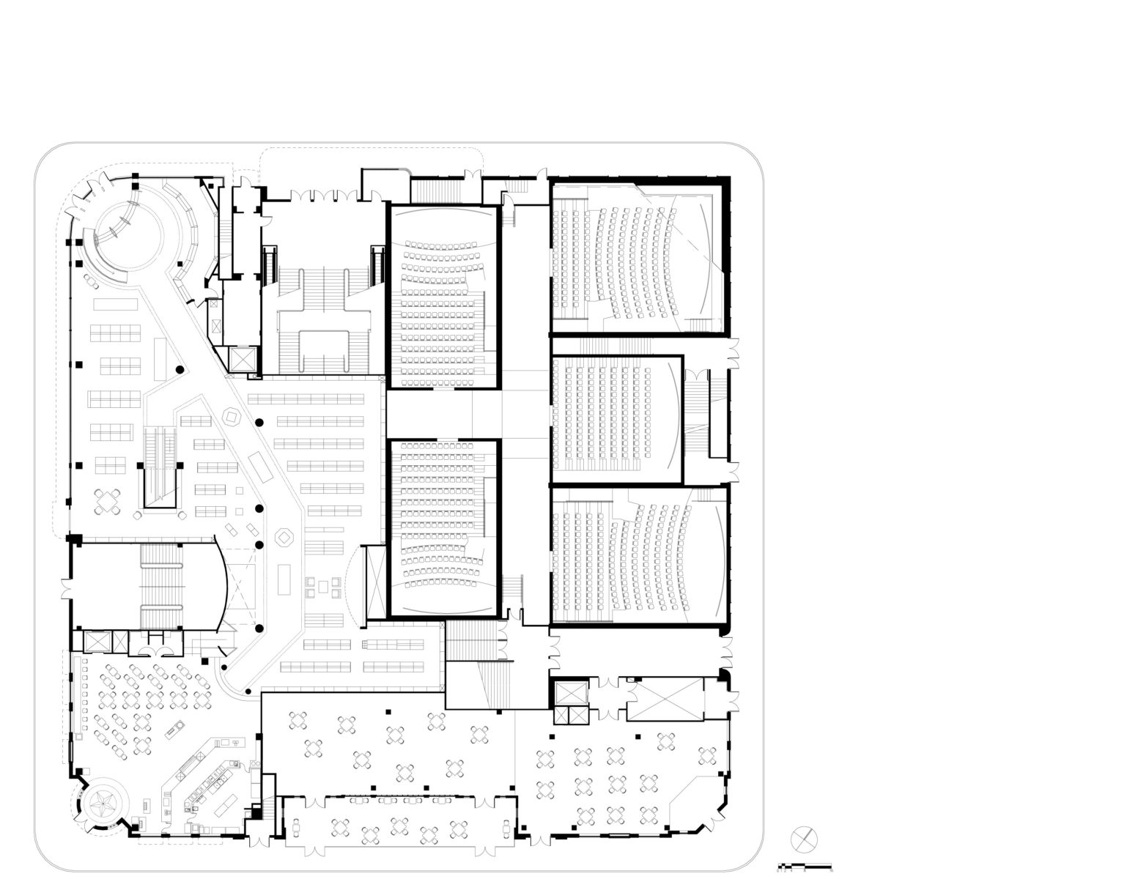

**Appendix D: Miscellaneous**

**Table 8**: Statistics 1. Texas Public Libraries Annual Report. (2021). Texas State Library and Archives Commission.

**Table 9:** Statistics 2. Texas Public Libraries Annual Report. (2021). Texas State Library and Archives Commission.

**Table 10:** Statistics 3. Texas Public Libraries Annual Report. (2021). Texas State Library and Archives Commission.

**Table 11:** Statistics 4. Texas Public Libraries Annual Report. (2021). Texas State Library and Archives Commission.

**Table 12:** Statistics 5. Texas Public Libraries Annual Report. (2021). Texas State Library and Archives Commission.

**Table 13:** Statistics 6. Texas Public Libraries Annual Report. (2021). Texas State Library and Archives Commission.

**Table 14:** Statistics 7. Texas Public Libraries Annual Report. (2021). Texas State Library and Archives Commission.

**Table 15:** Statistics 8. Texas Public Libraries Annual Report. (2021). Texas State Library and Archives Commission.

**Table 16:** Library Collection. (K. King, personal communication, September 19, 2022).

**Table 17:** More Offerings. (K. King, personal communication, September 19, 2022).

**Table 18:** Vendor Information. (K. King, personal communication, September 19, 2022).

