# Module 6: Evaluations Set 2 (Databases, Indexes, & Abstracts, Search Engines, Directories, and Serials)

Each student will evaluate the following **four (4)** sources:

* Databases, Indexes, & Abstracts: [ProQuest Research Library](https://libproxy.library.unt.edu/login?url=http://search.proquest.com/pqrl)
* Search Engines: [Bing.com](https://www.bing.com/)
* Directories: [State Bar of Texas Find a Lawyer](https://www.texasbar.com/AM/Template.cfm?Section=Find_A_Lawyer&Template=/CustomSource/MemberDirectory/Search_Form_Client_Main.cfm&Find=0)
* Serials: [Dallas Morning News](https://www.dallasnews.com/)

Review the Information Resources and Evaluation Criteria lecture and the lecture/readings associated with each type of source.

For each information resource selected, you will:

* Analyze the resource in depth.
* Write an **original** evaluation of the resource, which includes *authority, scope, and arrangement*. It is not required to use outside sources to write your evaluation. Information obtained to write your evaluations (either from the source or an outside source) should be properly cited and referenced according to APA format. **Do not copy and paste** information from the source itself; you should write your own critical analysis of the resource.
* Provide your recommendation for the type(s) of user group(s) for which this

**Evaluation**

Title of Source: [ProQuest Research Library](https://libproxy.library.unt.edu/login?url=http://search.proquest.com/pqrl) (Database)

**Authority** (minimum of 75 words):

ProQuest Research Library is a digital database that provides access to a wide range of academic journals, magazines, and newspapers. It was created by ProQuest LLC, a Michigan-based information and technology company that specializes in electronic research tools and services. ProQuest LLC was founded in 1938 as University Microfilms International (UMI) and has since grown to become a leading provider of electronic resources for academic, government, and corporate markets. The company offers a variety of digital products and services, including databases, ebooks, digital archives, and research tools. ProQuest agreed to be acquired by Clarivate, a leading global information services provider. In 2021. (*ProQuest Databases, EBooks and Technology for Research*, 2022)

Sources:

Mergent Intellect (2023.) ProQuest LLC.. Retrieved March 14, 2023, from https://www-mergentintellect-com.libproxy.library.unt.edu/index.php/search/companyDetails/118717529

*ProQuest | Databases, EBooks and Technology for Research*. (2022). Proquest.com. https://about.proquest.com/

**Scope** (minimum of 100 words) :

ProQuest Research Library is a digital database that provides access to a wide range of scholarly and popular articles, journals, and research materials. It is a subscription-based resource commonly used by researchers, students, and professionals to access reliable and up-to-date information on various topics, including business, health, social sciences, arts, and humanities. The types of media indexed in this database are periodicals.

Subjects covered:

Publication subjects include: Psychology, Education, Business and Economics, Law, Medical, Political, and Social Sciences and over 4,986 scholarly journals followed by 945 magazines and 900 trade journals are indexed.

ProQuest has LibGuides for search strategies and database selection help. When I clicked on one of the embedded videos, the link was broken. This database needs to be checked more regularly to bolster the reliability of its resources.

**Arrangement** (minimum of 100 words):

The layout is organized logically and the site map is easy to navigate. The search screens (both basic and advanced search boxes) are clean, simple interfaces without a lot of distraction and superfluous information. The advanced search allows for flexibility in terms of refining search results, including the ability to limit by publication date, language, and document type.

Proquest publication search lists 371,344 publications. These publications include audio and

video works, dissertations and theses, scholarly journals, historical periodicals, websites, podcasts

blogs and more.

ProQuest offers more flexibility Includes a title list of over 7,222 journals, digests, and publications. (the title list is downloadable into an xls spreadsheet for further examination of available titles).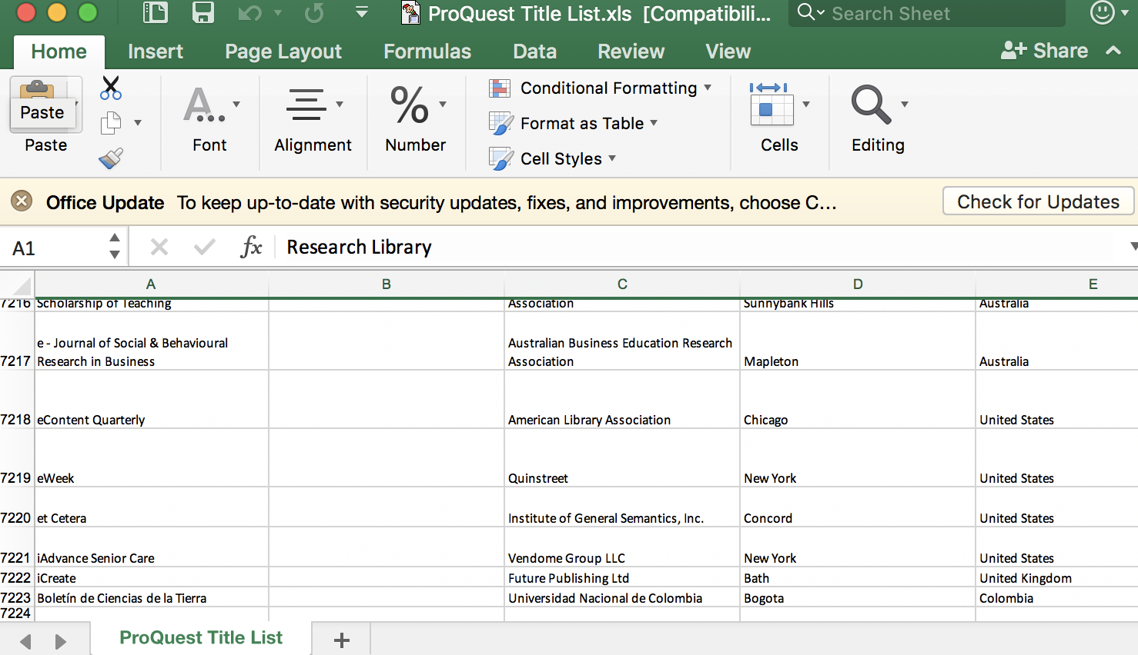

Access points:

Access points to the ProQuest Research Library can vary depending on the institution or organization that provides access to the database. Many academic or public libraries subscribe to the ProQuest Research Library and provide access to their users. Users can access the database using their library card or login credentials provided by the library. For example, UNT Libraries carries a subscription to ProQuest Research Library. ProQuest is a subscription-based product which is sold at the institution level only and one cannot purchase access to ProQuest Research Library directly from the ProQuest website (*ProQuest & Ex Libris Support*, 2023).

**Recommendation** (minimum of 75 words):

I would recommend this database because of its easily searched interface and robust access to a wide variety of resources including: academic journals, video, dissertations and theses, ebooks, newspapers, periodicals, historical collections, music scores, governmental and cultural archives. I also liked the help section which includes training (videos and text), libguides, and research skill-building. The help section helps to to find and refine a topic and delineate between primary and secondary sources. For someone starting out their research these tools can be valuable.(See embedded screenshot). 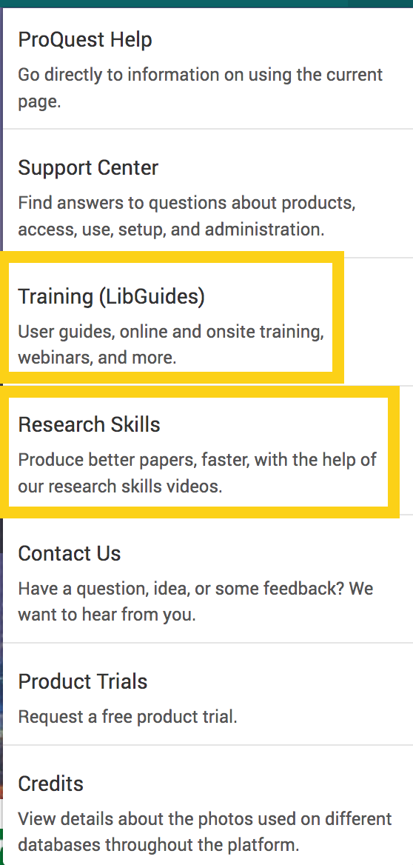

Sources:

*ProQuest & Ex Libris Support*. (2023). Proquest.com. https://support.proquest.com/s/article/Individual-subscription-to-ProQuest?language=en_US#:~:text=ProQuest%20is%20a%20subscription%2Dbased,provide%20the%20remote%20access%20instructions.**Evaluation**

Title of Source: [Bing.com](https://www.bing.com/)

Authority (minimum of 75 words):

Bing is a general search engine created and operated by Microsoft. It bears a copyright designation from 2023. Bing was launched in 2009 by software giant [Microsoft Corporation](https://www.britannica.com/topic/Microsoft-Corporation). There were several iterations of search engines powered by Microsoft before Bing came on the market. Bing has very recently garnered a lot of media attention for its “New Bing”, the Bing.com search engine infused with artificial intelligence. In fact, the New York Times published two articles within a day of each other about Bing’s resurgence in the search engine scene. According to Roose (2023), Microsoft’s release of a ChatGPT-powered Bing signifies a new era in search capabilities. The new Bing’s technology works by extracting search terms from users’ requests, running those queries through Bing’s search index and then using those search results in combination with its own language model to formulate a response. However, newly emergent technology is not without its foibles and glitches, and Bing is no exception. Roose (2023) says the new Bing AI is not ready for use as it renders incorrect answers and bizarre emotional responses in the chat feature.

Sources:

Bing. Description & History. Britannica. (2023). In *Encyclopædia Britannica*. https://www.britannica.com/topic/Bing-search-engine

‌Roose, K. (2023). Bing (Yes, Bing) Just Made Search Interesting Again.. *The New York Times*. <https://www.nytimes.com/2023/02/08/technology/microsoft-bing-openai-artificial-intelligence.html>

Roose, K. (2023). A Conversation With Bing’s Chatbot Left Me Deeply Unsettled. *The New York Times*. https://www.nytimes.com/2023/02/16/technology/bing-chatbot-microsoft-chatgpt.html

Scope (minimum of 100 words) :

**Examine fields covered**

**Examine stated limitations**

**Comparisons with other resources**

The stated purpose of Bing.com is to provide users with a powerful search engine that delivers relevant and accurate search results, and to help users make informed decisions by organizing information in a useful way. Bing.com aims to accomplish this by using advanced algorithms and AI technologies to understand the user's intent behind their search query and provide the most relevant and helpful results possible The source of this information is Microsoft, the company that owns and operates Bing.com. Microsoft has publicly stated the purpose and mission of Bing.com on its website and in various company communications. (*Microsoft Bing*, 2023). Some limitations of Bing.com, described in the Authority section above, relate to its imperfect AI Chatbot feature, which results in incorrect answers to queries and bizarre emotional responses.

‌*Microsoft Bing*. (2023). Microsoft.com. https://www.microsoft.com/en-us/edge/bing?form=MA13FJ

Arrangement (minimum of 100 words):

There’s a search box that has predicted text and auto populates what it thinks

you will type. The predictive text feature is designed to save time and reduce typing errors.

Bing.com can be accessed through various access points, including:

1. Web browser: The most common way to access Bing.com is through a web browser. Users can simply enter the URL bing.com into the address bar of their web browser to access the search engine.
2. Mobile apps: Bing.com is also available as a mobile app for iOS and Android devices. The app can be downloaded from the App Store or Google Play Store.
3. Windows search: Bing.com is integrated with the Windows operating system and can be accessed through the search bar on the taskbar or Start menu.
4. Microsoft Edge browser: Bing.com is the default search engine for Microsoft Edge, the web browser developed by Microsoft.
5. Cortana: Cortana is the virtual personal productivity assistant developed by Microsoft and is available on Windows 10 and other devices. Users can ask Cortana to perform a search as it will use Bing.com.
6. Bing can also be accessed via Skype (The New Bing Preview Experience Arrives on Bing and Edge Mobile Apps; Introducing Bing Now in Skype - the Official Microsoft Blog, 2023).

Recommendation (minimum of 75 words):

I would not recommend Bing.com as a search engine. The advertisements are distracting compared with the smooth, streamlined interface of a general search engine like Google. Bing automatically finds your location (either via IP address or default browser settings) and so for me, the site is in Japanese along with all of the advertisements. I was able to change the language to English but it does a word for word translation that isn’t meaningful when looking at the content. Ultimately, this is frustrating for me. The location can be changed in the browser, but even in order to obtain information about Microsoft, I needed to use a VPN to make it look like I was in the US. I don’t have these kinds of issues with Google and that is why it is my preferred search engine of choice. I also didn’t like how Bing automatically logs in my UNT email address which is through hotmail, a Microsoft product.

**Evaluation (Directory)**

Title of Source: [State Bar of Texas Find a Lawyer](https://www.texasbar.com/AM/Template.cfm?Section=Find_A_Lawyer&Template=/CustomSource/MemberDirectory/Search_Form_Client_Main.cfm&Find=0)

**Authority** (minimum of 75 words):

The State Bar of Texas Find a Lawyer is a free directory service run by The State Bar of Texas to help members of the public find attorneys who are licensed to practice law in the state of Texas. The State Bar of Texas site and the directory are shown copyrighted in 2023. There is a site map, which I always find to be useful in locating content and observing what a site has on offer. There are services in both English and Spanish and for the general public and for attorneys. The State Bar of Texas is a public corporation and an administrative agency of the judicial department of the Texas government (State Bar of Texas. Our Mission, 2023).

**Scope** (minimum of 100 words) :

The user of the directory is presented with an alphabetical list of potential reasons to see an

attorney, displaying everything ranging from Accidents and Injuries to Trusts. You can also filter by

location of the lawyer and where they attended law school with the schools listed in alpha order.

Clients can select by language spoken, although it should be noted that the website is in English.

A Spanish menu can be found under the For the Public tab (see screenshot below).

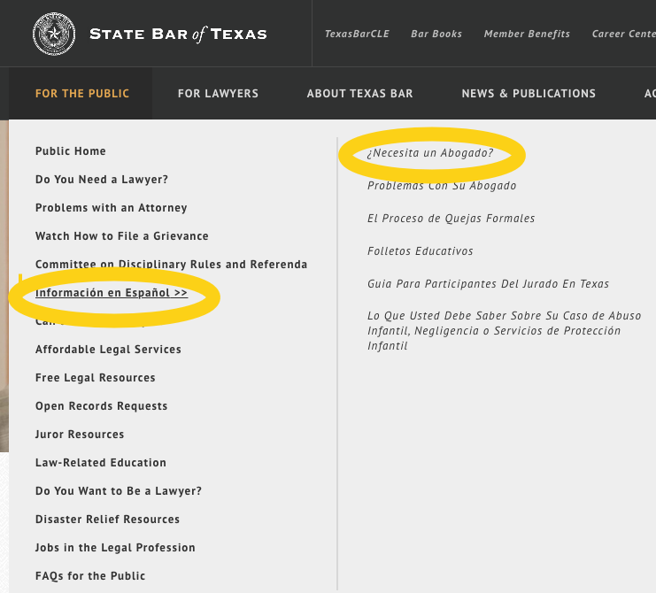

However, one of the limitations of the directory is that once a member of the public clicks on ¿Necesita un Abogado?, they are directed to [**BÚSQUEDA ELECTRÓNICA DE ABOGADOS**](https://www.texasbar.com/AM/Template.cfm?Section=Find_A_Lawyer&Template=/CustomSource/MemberDirectory/Search_Form_Client_Main.cfm) which is the [State Bar of Texas Find a Lawyer](https://www.texasbar.com/AM/Template.cfm?Section=Find_A_Lawyer&Template=/CustomSource/MemberDirectory/Search_Form_Client_Main.cfm&Find=0) directory in English. Another limitation is that the State Bar of Texas makes “no warranty or guarantee concerning the accuracy or reliability of the content at this site or at other sites to which we link” (State Bar of Texas. Home, 2023).

There are some special features embedded in the directory, namely the LRIS, or the Lawyer Referral Information System. LRIS offers an automated online referral system which purports to offer Texans access to legal help (in the form of an initial consultation to last no more than 30 minutes) for no more than $20.

**Arrangement** (minimum of 100 words):

I found the arrangement of the directory to be a bit clunky, with advertisements for State Bar of Texas merchandise which can be a little distracting popping up on the side bar, at the top of the page, and down at the bottom of the page. It really depends on who the primary audience for the directory is supposed to be. Is it the public? Or Texas lawyers? The State Bar of Texas serves both populations and they attempt to provide resources for both. From a design and accessibility perspective, I did like the alpha options in the drop-down menus for finding what you need help with, languages the attorney speaks, and fee-options. The five fee option plans displayed offer a wide range of payments for an economically and socially diverse population and is a comprehensive representation of options.

**Recommendation** (minimum of 75 words):

I found the directory to be useful, however, the Spanish language features are not on the home page and I didn’t think they were intuitive to find. Once you get to the [**BÚSQUEDA ELECTRÓNICA DE ABOGADOS**](https://www.texasbar.com/AM/Template.cfm?Section=Find_A_Lawyer&Template=/CustomSource/MemberDirectory/Search_Form_Client_Main.cfm) link, it takes you to the Find a Lawyer Directory. The entire directory and the drop-down menus to make your selections are in English, which is not helpful for Spanish-speaking/reading users. The LRIS embedded referral system is also only available in English. From an accessibility standpoint, this directory would score low points, especially in a state such as Texas, where over ⅓ of Texas residents speak Spanish.

**Evaluation (Serial)**

Title of Source: [Dallas Morning News](https://www.dallasnews.com/)

**Authority** (minimum of 75 words):

The Dallas Morning News online edition is a digital news platform that provides news, analysis, and commentary on local, national, and international events (n.b. primarily local, in the Dallas-Fort Worth metroplex). This online serial is published by DallasNews Corporation (NASDAQ: DALN), the Dallas-based holding company of *The Dallas Morning News*. The DallasNews Corporation touts itself as the oldest continuously operated business in Texas, going back to 1842. Dallas Morning news has been awarded eleven Pulitzer Prizes since 1986. The Pulitzer Prize is an annual award that recognizes excellence in American journalism and is widely regarded as a symbol of exceptional talent and integrity, placing the Dallas Morning News in high authority.

Source:

<https://www.dallasnewscorporation.com/about/>

<https://www.dallasnewscorporation.com/about/journalism-awards/>

**Scope** (minimum of 100 words) :

The Dallas Morning News online edition is updated and published continuously throughout the day, every day of the week. This serial publishes local, national, and international news, however the newspaper has a strong focus on local news and events in the Dallas-Fort Worth metroplex. I noticed a majority of the articles featured heinous crime and some articles on the arts and sporting events. Readers can access the latest news, information, and analysis at any time of the day or night. The online edition of The Dallas Morning News includes articles from the print edition of the newspaper, as well as exclusive content that is only available online. The website also features multimedia content, such as photos, videos, and podcasts, and offers readers the ability to customize their news feeds based on their interests and preferences and to sign up for newsletters.The Dallas Morning News offers email newsletters that provide subscribers with daily or weekly updates on specific topics, such as breaking news, sports, business, and entertainment.

Sources:

Dallas Morning News. (2023). About us. Retrieved from<https://www.dallasnews.com/help/about-us/>

Dallas Morning News. (2023). Newsletters. Retrieved from<https://www.dallasnews.com/newsletters/>

**Arrangement** (minimum of 100 words):

[Dallas Morning News](https://www.dallasnews.com/) is an electronic newspaper (serial) containing special features such as podcasts, where “readers” can listen to the Dallas Morning News in a podcast feed of their choice, or through Amazon’s Alexa. Additionally, there is Al Día, the Spanish-language news and information platform that is published as a supplement to The Dallas Morning News. The publication provides coverage of local news, events, and issues that are of interest to the Hispanic community in the Dallas-Fort Worth metroplex.

The Dallas Morning News has many sections, among them: News, Business, Sports, High School Sports, Arts & Entertainment, Food, Go See DFW, Opinion Sponsored Content, More (including Obituaries and Celebrations), Guides, and the aforementioned Al Día. Additionally, there is a weekly magazine supplement called Parade that is included with The Dallas Morning News on Sundays. Parade is known for its coverage of celebrity news, human interest stories, and lifestyle topics. There is also a weekly entertainment planner called guide published by Dallas Morning News.

Source: <https://epaper.dallasnews.com/app/DAMONE>

**Recommendation** (minimum of 75 words):

I would recommend this online serial to readers (and also to listeners of the podcast). The online version of the paper is streamlined and easy to navigate. The pages are not cluttered by advertisements or superfluous content. (The advertisements exist, but are minimal and not intrusive). If you are not a subscriber to the newspaper, you are unable to log-in to access the e-version of the paper, but this is not a deal breaker. The different sections of the paper are clearly delineated by clicking on Sections in the upper left-hand corner of the home page. The home page is not overly cluttered and is user-friendly to navigate to topics and articles of interest. However, if you’re looking for international news, this is probably not the paper for you. I did find an article about the war in the Ukraine dated March 13th and this was located in the Politics section of the paper, but otherwise the focus is on the DFW metroplex and the state of Texas.