**Evaluating a Book and an Institution**

Lindsay Robbins

INFO 5450: Rare Books

Dr. Jennifer Sheehan

November 29th, 2021

Part A: Institution Assessment

I requested to view the *Inicipit [sic] Tractatus de virtutibus herbarum*, also referred to as the *Herbarium Latinum*, attributed to Arnaldus de Villanova at the UT Dallas Special Collections Richardson, Texas. The object I viewed is currently housed at the Eugene McDermott library on the 3rd floor in the McDermott suite. The suite is locked at all times and requires a prior appointment in order to gain access. Within the suite there are several offices for staff, with objects located at the back. There were several display cases, though they were empty, and most items appeared to have been shelved and not openly on view. There are a number of special collections affiliated with the university, including the Louise B. Belsterling Botanical Collection, the History of Aviation Archives, the rare books collection, general university archives and the Wineburgh Philatelic Research Library. Some of these collections are also housed in the Eugene McDermott library, while others such as the History of Aviation Archives are housed nearby in another building.

Those requesting to view materials must make an appointment in advance. I filled out a research request form and emailed it to library staff per the instructions on their webpage, however one of the staff members overseeing the special collections indicated that I needed to only schedule an appointment to come in. I scheduled a day but was not prompted to provide an exact time. When I reached the circulation desk at the first floor of the library I asked where I could find the special collections. Before being given directions, the staff member made sure I had requested a prior appointment. The room, as far as I could tell, was only able to be accessed through one door. The ALA recommends to special collections staff that personal items be kept in a separate receiving room, but surprisingly, I was permitted to have my backpack with me in the same room as the materials (2009).

When I arrived, the book had already been laid out on a table for me and I confirmed that I was allowed to take photos without flash and have my laptop out to take notes. I was also expected to have clean hands and a facemask. The archivist sat at a table nearby, likely in order to monitor me, which is logical considering that the object is the oldest item in the collection. There were no other visitors when I arrived, which may have been intentionally planned. Even if this was not the case, however, tables were spaced far enough to allow for social distancing if necessary. I was surprised there were not more COVID-19 precautions in place and was prepared to only be able to view the object online. Earlier this year, an online session hosted by the IFLA Rare Books and Special Collections section discussed topics related to rare books and special collections during the COVID-19 epidemic. In this session, several curators and librarians of special collections discussed specific concerns about the pandemic in regard to their archives. When prompted to speak about restrictions for in-person access, Peter Sjökvist, curator at Uppsala University Library in Sweden, indicated that they were practicing social distancing in their reading room but that they were rarely turning people away (Martín, et al., 2021). UTD seems to be treating their reading room similarly.

I was surprised that not more of the book was made available online. Many archives are putting a huge amount of time and resources into digitizing collections, and as the oldest book in the collection, it could be a good asset to choose for digitization. There are likely other copies in existence, but as we have observed in our classwork, individual differences in copies can be important indicators of provenance. This is affirmed by Overholt as well, as he states that “every physical quality they possess is a potential piece of historical evidence” (2016, p. 79). Especially when taking the herbarium into consideration, the physical viewing of the object for me was nothing like what I had expected when I viewed the item online beforehand. There are only two pages available to view online and they do not show the patchwork quality of the book that is so evident in person. Digitizing could also be beneficial in identifying missing or damaged pages and in the best case, even help reunite missing portions as noted by Cullingford (2016, p. 114).

Overall, the process was simple, though I was somewhat confused initially about the proper way to request an appointment. The form I filled out prior seemed somewhat dated, and the link on the form was not operating properly, so it could be beneficial for future visitors to have this corrected. Otherwise, all of the procedures outlined on the Eugene McDermott’s special collections policies page were in place (2021). I was also somewhat surprised that aside from the form, there did not seem to be anything for me to fill out. If I had damaged the book, I am unsure how the institution would find me aside from my email address that I used for communication, since the form was apparently not necessary. Southwell summarizes a report from the ARL that found that 97% of special collections libraries require some sort of form to be filled out by the visitor, however, these forms vary widely in their content (2007). After previous experiences, I agree with the author that some sort of standardization could help with security as well as improving researchers’ experiences (Southwell, 2007). There is no guarantee, however, that measures such as collecting visitor information, supervising visitors, and keeping access to materials limited will ensure the item’s safety, as Higgins explains, stating that materials are still lost frequently even with precautions in place (2015).

Part B:

Overall, visually the book shows its age. The majority of the pages have mold and wormholes as well as small tears at the edges of many pages. It looks as though the book has been removed from its original cover and placed in a newer case that is somewhat plastic-like in appearance. There is a split as the top joint, though the spine appears to be in good condition otherwise. The cover itself is very thick, study and in good condition with no ornamentation or markings outside of basic information on the spine. The pastedowns appear to be made of a different material in comparison to the rest of the book and they appear to be less aged than the rest as well. There are no noticeable markings on the pastedowns. The text block has significant wear, with many pages sticking out farther than others; nearly all of them exhibit what is likely water or mold damage as well as general wear-and-tear. Pages vary in size, though most are approximately 8 in. tall. This variation in size is in large part due to what appears to be the inclusion of facsimile pages which are less weathered than the majority of the pages in the book. Indicated by the item’s catalogue page, the tome is a quarto at 22 cm tall (UTD, n.d.). Many of the pages are not numbered, and the total number of pages is hard to determine with the recreated pages in place, though each section has a Roman numeral.

There is a title page with the latin title, *Incipit Tractatus de Virtutibus Herbarum*, though it is printed on paper that is newer in appearance and was likely added later. The author is mentioned on the following page at the top. Otherwise, the only indication of the author, title and date come from the cataloguing of the item. The title is listed on the spine as *Herbarium Latinum* as well as the location, Venice, and the year 1499. This information is also included in a colophon on the final page noting Simon Bevilaqua as the printer of the book in Venice with the precise day—December 14th, 1499 (Fig. 1). The contents of the book appear to be utilitarian in nature. There is an index at the front of the book with included sections listed in alphabetical order, each with its own designated Roman numeral. There is not much to help the reader navigate however, as there are not page numbers for each entry. There are, however, signature marks as can be seen in Figures 2 and 3. The contents are in Latin and seem to describe each of the listed herbs. All of the herbs also appear to have an illustration included such as Absinthium (Fig. 2). Provided that all herbs have one illustration, there should be approximately one-hundred fifty illustrations as there are the same number of sections noted at the beginning of the book. The illustrations are contour drawings displaying each herb, each image is large, typically covering about half of each page they are featured on. These images are simple and show the roots as well as the body of what the plant would look like above ground. The illustrations feel utilitarian in appearance as well. While they are pleasing to view, they lack color and do not seem to have been embellished in any way. I would argue that these are likely wood-cut illustrations due to the use of woodblock illustrations in this period (Drucker, n.d.), as well as the quality of the lines. These images do not require a great amount of detail to be carved, and the ink appears to have spread at many of the edges of the leaves. There is a quality to the lines that feels as though the details have been carved to stand out as well.

The texture of the newer-looking paper feels very soft where the older pages feel more coarse and there do not appear to be any obvious chain lines or printers’ marks anywhere. The two types appear to have faint laid lines, however. These laid lines are more visually apparent in the newer, softer material, though it is difficult for me to tell if these marks are due to the texture of the paper itself or if there are in-fact laid lines. Considering that this book was printed in Venice in 1499, it is likely that it is made from laid paper, as paper was used as early as the 11th century in Europe (Drecker, n.d.). The words appear to have been printed as well, rather than hand-scribed, and this would be logical for the time considering that Venice was a hot spot with more than two hundred printing presses in operation prior to 1500 (Drecker, n.d.).

This book appears to have been heavily used. The general wear is very apparent and many of the older pages have been repaired with newer material as can be seen on the corner of this page in (Fig. 4). There are several markings and small notes in the book margins which appear to have been penned in a sharp-tipped instrument like a quill. They are nearly illegible, though they appear to be in Latin or another foreign language, and the ink is extremely faded (Fig. 5). Some passages are also underlined or marked with a cross, so this may have been used as a study reference. There are some faded markings which may have been made in graphite at the top of the first herb listing but there are difficult to read. These may denote an owner at some point in the book’s provenance. The only other obvious sign of ownership is the cataloguing information on the title page indicating where the book should be located, which matches the current information for the book as it is listed in the UT Dallas catalogue. With these elements in consideration, this seems like it was a well-used quick reference or study material for the use of particular herbs at the time of publication.

References

Association of College & Research Libraries. Guidelines regarding security and theft in special collections. American Library Association. (2009, October 5). http://www.ala.org/acrl/standards/security_theft

Cullingford, A. (2016). Digitization and digital libraries in special collections. In *The Special Collections Handbook* (p. 114). Facet Publishing.

Drucker, J. (n.d.). The middle ages in the west and east. In *History of the Book*. UCLA. <https://hob.gseis.ucla.edu/HoBCoursebook_Ch_4.html>

Drucker, J. (n.d.). The invention and spread of printing. In *History of the Book*. UCLA. <https://hob.gseis.ucla.edu/HoBCoursebook_Ch_5.html>

Eugene McDermott Library. (2021, November 2). Special collections policies and procedures. The University of Texas at Dallas. <https://library.utdallas.edu/special-collections-and-archives/special-collections-policies-and-procedures/>

Higgins, S. (2015). Theft and vandalism of books, manuscripts, and related materials in public and academic libraries, archives, and special collections. *Library Philosophy and Practice*, 1256.

Martín, A., Periasamy, M., Sjökvist, P., & Stillo, S. (2021, February 10). *Rare books and special collections adapting to a global pandemic* [Webinar]. IFLA Rare Books and Special Collections. <https://iflarbscs.hypotheses.org/728>

Overholt, J. (2016). Collecting printed books in a digital age. In Thomas, L. M., & Whittaker, B. M. (Eds.), *New directions for special collections: An anthology of practice*. (pp. 77-80). ABC-CLIO, LLC.

Southwell, K. (2007). The use of registration forms in special collections libraries. *Collection Management, 31*(4). 77-93. https://doi.org/10.1300/J105v31n04_06

University of Texas at Dallas. (n.d.). *Inicipit [sic] Tractatus de virtutibus herbarum*.

<https://utdallas.primo.exlibrisgroup.com/permalink/01UT_DALLAS/2hgl0t/alma9917005001421>

Villanova, A., & Bevilaqua, S. (1499). *Inicipit [sic] Tractatus de virtutibus herbarum*. https://utdallas.primo.exlibrisgroup.com/permalink/01UT_DALLAS/2hgl0t/alma9917005001421

List of Figures

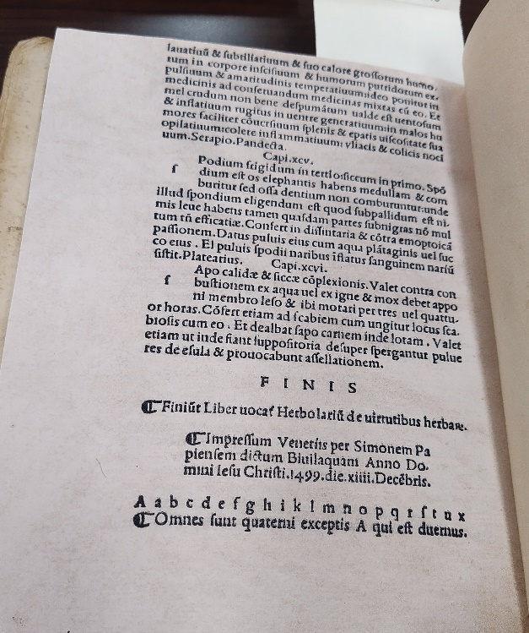

*Figure 1*: Colophon

*Figure 2*: Signature mark a

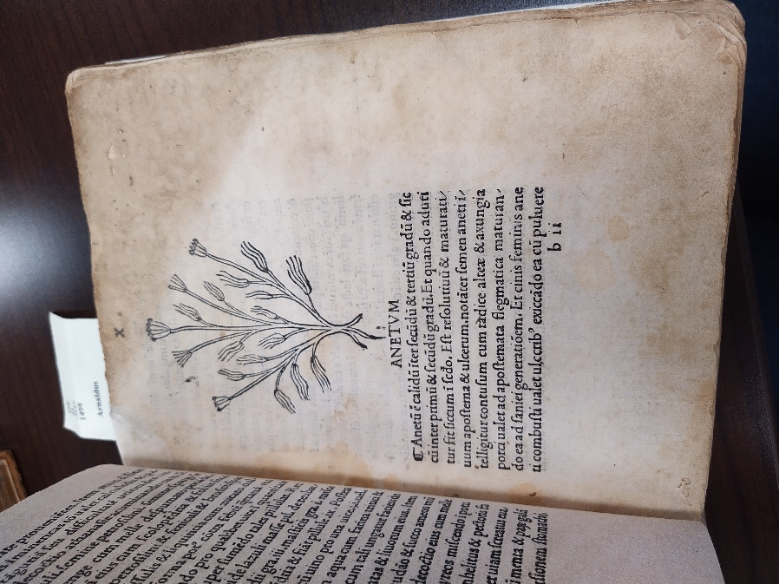

*Figure 3*: Signature mark bii

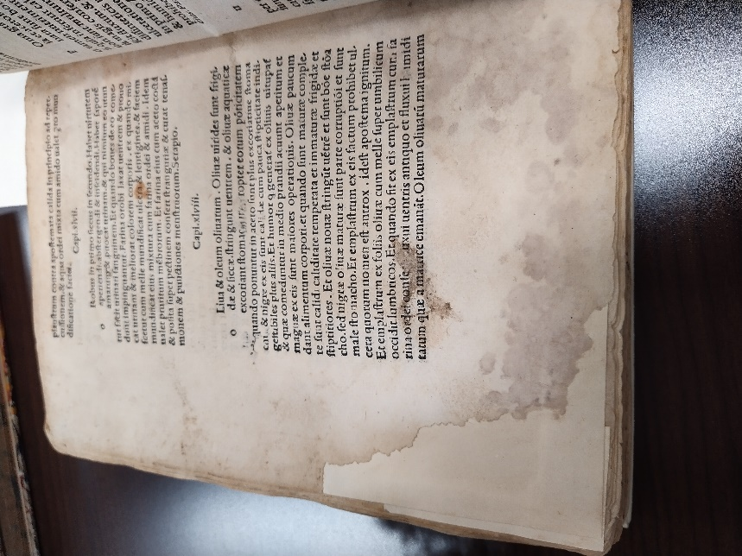

*Figure 4*: Repaired corner page

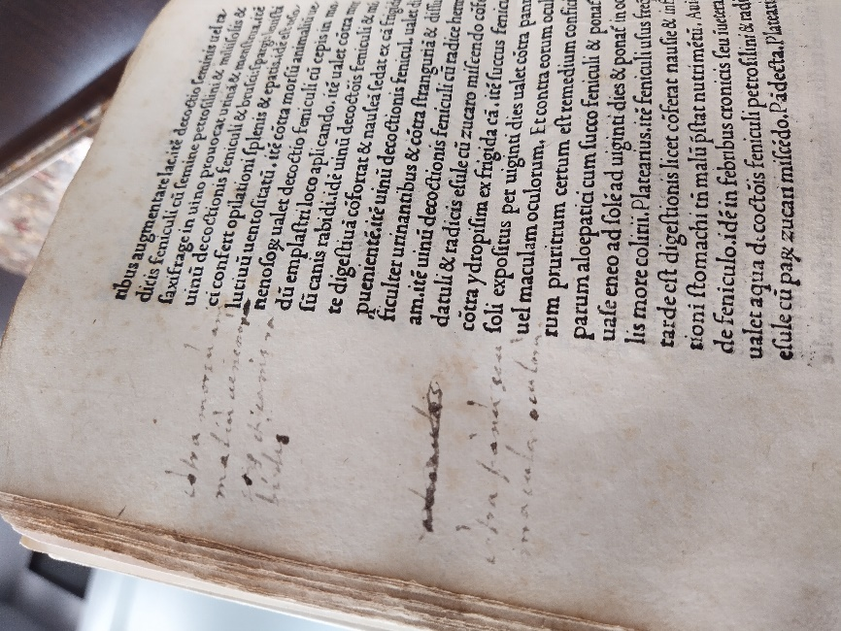

*Figure 5*: Notations in the margins