I became a student member of the American Library Association and attended two live webinar sessions. One of the webinars was hosted by the ALA in general and one was hosted by one of the round table groups that I joined. I joined a total of thirteen round tables and while many of them are not extremely active, the GameRT (Games and Gaming Round Table) has frequent webinar sessions.

The first session I attended, “Copyright Decision Making, Step-by-Step”, was hosted by the Association of College and Research Libraries division of the ALA and presented by Carla Myers, an employee of the Miami University Libraries who works as the Assistant Professor and Coordinator of Scholarly Communications. She is an expert on copyright and its context in libraries and other learning environments. I was interested in this presentation in particular because copyright and fair use are some of the more interesting topics in LIS to me personally. I was especially curious to see if they would be speaking about blockchain technology or NFTs since I am writing about these topics for literature review. It seems that these topics may be too new, however, and also perhaps too specific as they were not addressed. Much of the material covered was contained in chapter 31 of our textbook, *Information Services Today*, as well as materials from other classes. Despite this, however, it was still a valuable session as the information was presented by a professional who deals with the situations mentioned in the text on a day-to-day basis. She receives many inquiries from staff at her university about what could constitute as fair use or a potential act of copyright infringement and some of the situations were surprising. For example, a student group wanted to show a movie at the university and also invite members of the public. While showing the movie to the club members would not be a violation, opening it up to the community would be. It is a good reminder that as an information professional dealing with copyrighted materials on a daily basis that we be mindful and refresh ourselves on current standards in order to protect ourselves and our institution.

The second session I attended was hosted by the GameRT community of ALA and was presented by Lindsay Cesari, a junior high school librarian at Baldwinsville Central Schools in New York. The presentation, “Build Community & Information Literacy with Esports”, was focused on advising viewers on how to create and foster an Esports team at their local information institution. While the information from this session could likely be implemented at any variety of institutions, it was focused most on primary school library settings. Cesari touched on many of the aspects concerned with starting an Esports group from more technical aspects such as acquiring computers and other necessary technology to soft skills like having empathy for students and understanding how to help foster community among members. I was provided a recording of the session which is valuable as a future asset if I do find myself in a situation where it would be practical to implement.

Something I could have done better would be to have reached out to other groups sooner to see if there were earlier sessions that would have been more applicable to me. Under normal circumstances, the ALA may not host as many online sessions as they have been recently due to COVID-19 concerns. In this case, this worked in my favor, but for future professional development I will need to look farther ahead, especially if sessions require travel. While informative and interesting, the session hosted by GameRT may not apply to me depending on the type of information institution that I work in. I could likely implement an Esports team at a university library, but it would probably not be as beneficial in an archive setting, even if it was possible. I spoke very little in both of these sessions in the chat logs, but I did not have many specific questions to ask as I have not been in enough situations where I would need to find solutions beyond what was provided. Many of the viewers in both already seemed to be working professionals with specific issues they needed help in addressing. In future sessions I would want to reach out to anyone in the session that works in a related area to me which could lead to a good support network. It would also be beneficial to focus on and be aware of the most personally applicable webinar sessions hosted by the ALA and other groups as they have a constant flow of workshops and other materials available that are good resources for professional development. I want to use these resources as tools to help build a professional peer network so that we can help each other and point each other to help when needed.

Appendix

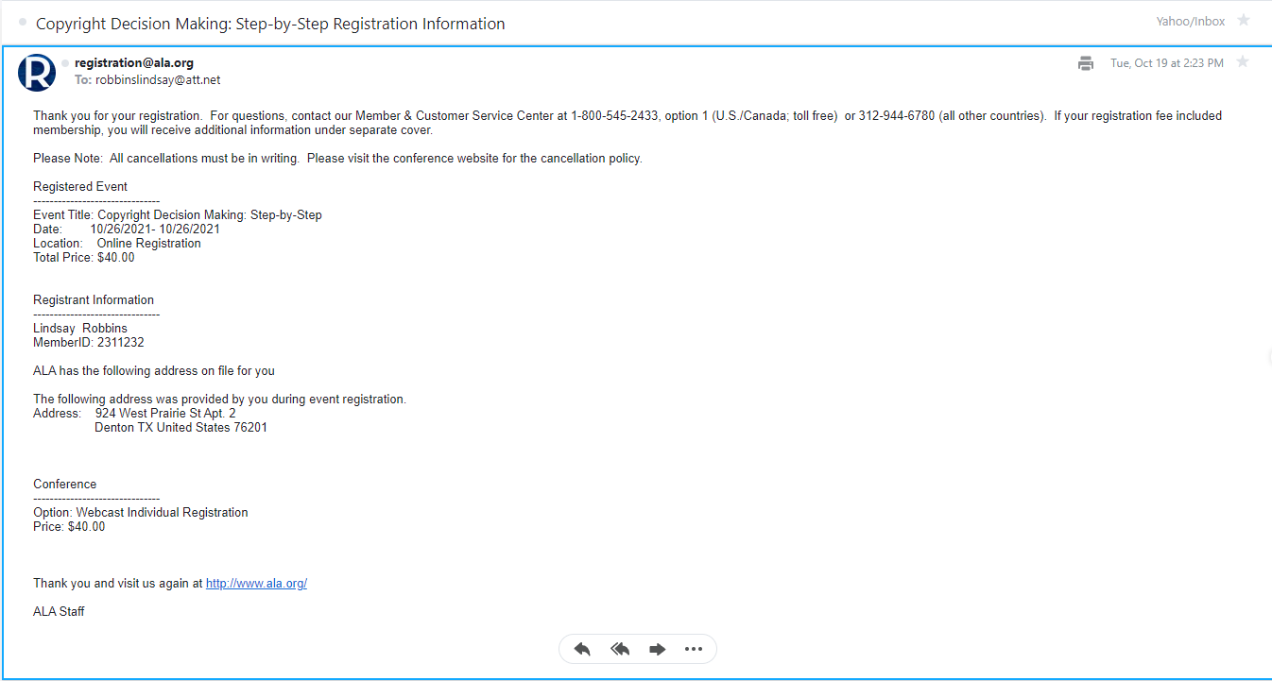Fig. 1: Copyright Decision Making Registration

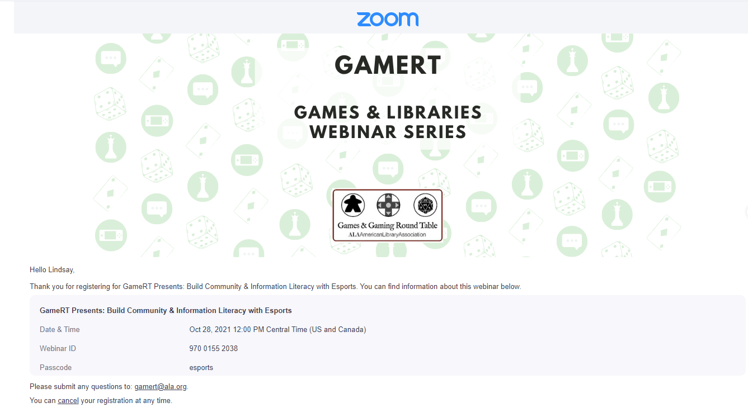

Fig. 2: Build Community & Information Literacy with Esports Registration