**Henriette D. Avram: A Digital Revolutionary**

Jen Van Ness

Department of Information Science, University of North Texas

INFO 5208: Learning Resources Organization

Dr. Barbara Schultz-Jones

December 4, 2022

**Abstract**

Henriette D. Avram was a pioneer in library automation and bibliographic control with an illustrious career spanning over three decades. Although she was not a librarian by training, her impact on the global library community was extensive and distinguished primarily by her contributions to the development of the Machine Readable Cataloging (MARC) format. Her work in developing MARC has had long-reaching implications for libraries all over the world and is used in libraries even today. Remarkably, MARC eliminated the need to create paper library catalog cards; bibliographic information was instead read and interpreted via a computer. In fact, because of MARC, patrons are able to search on the internet via an online public access catalog (OPAC), obviating the need to be physically in a library in order to perform a search, increasing access to bibliographic resources.

*Keywords:* MARC, cataloging, Avram, library, bibliographic control, OPAC

**Henriette D. Avram: A Digital Revolutionary**

The creation of bibliographic machine-readable cataloging (MARC), spearheaded by Henriette D. Avram at the Library of Congress in the mid-1960’s revolutionized libraries and changed the face of librarianship all over the world.  Most notably, Avram did not just stop at developing the structure of MARC, but instead worked tirelessly to establish MARC as the foundation for library automation everywhere.  Her dedication came to fruition as MARC became the worldwide standard. (Fox, 2006).

**MARC**

Avram was a computer analyst by training and her programming expertise served her well at the Library of Congress where she was employed from 1965 to 1992. Her role was primarily to analyze cataloging data in order to discern their ability to become machine (computer) manipulated (Rather and Wiggins,1989a).  In addition to bringing her programming prowess, one of her many talents was successfully bridging the gap between librarians and computer analysts on staff at the Library of Congress. With her background in computer analysis, Avram took great care to elicit the opinions and expertise of the librarians at the Library of Congress in order to further understand the world of cataloging and fill in her knowledge gaps. Her determination to understand library science as it relates to cataloging was integral in propelling library science forward into a field which relied upon data and the transference of information. Library science and librarianship as it existed became transformed into information science under Avram’s focus and dedication to MARC. Her skills as a systems analyst were brought to the fore in the creation of MARC; Avram helped to develop an original code (example of which is shown in Figure 1) consisting of “cataloging numbers, letters and symbols to denote different elements, or fields, of bibliographic information” (Schudel, 2006). The MARC data structure made it possible to migrate information from a paper cataloging card to a computer. The ensuing computerized system was disseminated amongst a greater network of libraries giving way to a more open access to materials.

**Figure 1**

*Catalog Identifying Suitable MARC Records*

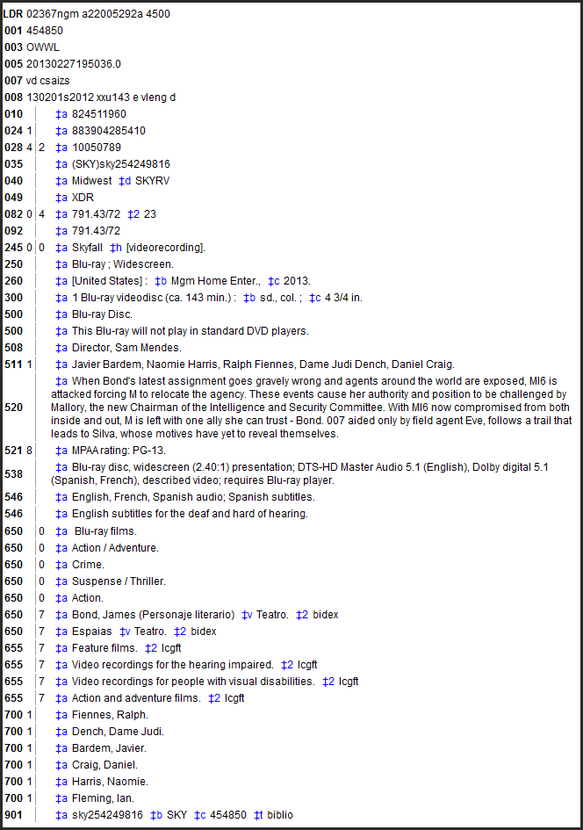

*Note.* Catalog Identifying Suitable MARC Records. (2022). OWWL Docs. <https://docs.owwl.org/Evergreen/CatalogIdentifyingSuitableMarcRecords>

According to Furrie (2003), “using the MARC standard prevents duplication of work and allows libraries to better share bibliographic resources. Choosing to use MARC enables libraries to acquire cataloging data that is predictable and reliable.” This level of deduplication saved countless hours of work and enabled the wide sharing of information.

**Significant Contributions**

Avram’s invention made possible the wide sharing of information through the support of the Library of Congress.  An insightful interview with Avram conducted by Rather and Wiggins (1989b) supports her involvement in the implementation of MARC in the early years getting the pilot project off the ground. Remarkably, the pilot project was completed quickly, in 1968, and, starting the very next year, bibliographic records were dispatched on magnetic tape to libraries across the country. (See Figures 2 and 3)

**Figure 2**

*Henriette Avram with bibliographic records on magnetic tape*

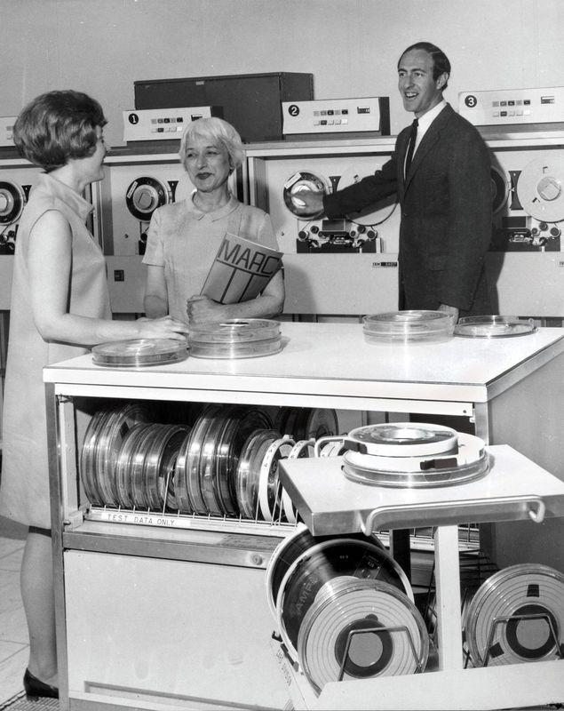

*Note.* Photograph 1: The Card Catalog: Books, Cards, and Literary Treasures. Chronicle Books, 2017.

**Figure 3**

***Henriette Avram presents a role of magnetic tape***

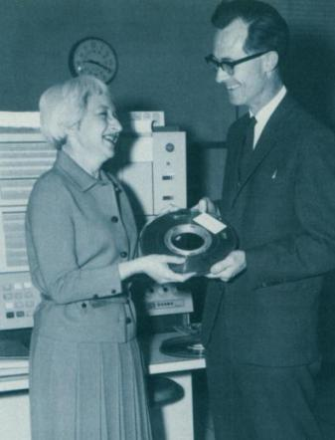

*Note: Henriette Avram presents a roll of magnetic tape holding over 9,000 bibliographic records to Richard Coward of the British National Bibliography (1967). American Libraries October 1989.*

Henriette Avram was a changemaker, always striving towards advancement; with the example of MARC, her goal was to push for the invention becoming the benchmark. Her work and dedication in the mid to late 1960’s with the pilot program and early distribution of MARC led to the national standard for electronic cataloging in 1971. After this accomplishment, MARC was then awarded the international standard in 1973. (Fox, 2006).  Most importantly, the adoption of the international standard made way for international libraries to deduplicate work and share records. Additionally, the international standardization led to the development and employment of library management systems (LMS) or integrated library systems (ILS), both of which enabled libraries to automate many of their functions. Avram assumed increasingly greater responsibility in her roles at the Library of Congress, rising to take on the oversight of a sweeping technical services operation. In fact, Avram became the Library of Congress’s first ever director of processing systems, networks and automation planning in 1980. (“They Won”, 1997).  At LC, she created and increased both cataloging and automation internationally, and she established a training office for technical processing. In addition, she continued to publish prolifically, publishing about 100 papers, books, and articles in bibliographic control and taking on many speaking engagements. She had such a wide-ranging impact that she was the recipient of over a dozen prestigious awards from 1971 to the end of her tenure at the Library of Congress. (Rather and Wiggins,1989a).

**Conclusion**

Avram’s impact in the development of MARC was so wide-reaching, that “without this communication format for bibliographic data, we would not have had automated library systems, bibliographic utilities, shared cataloging, resource sharing, and networking” (Pattie, 60).  Her contributions to the field of library and information science were significant and continue to have far-reaching implications in libraries everywhere today. Under the guidance and vigilance of Henriette Avram, computer science and library science were transformed from two disparate fields into one interwoven discipline. Computer skills became an integral part of shaping the framework of librarianship we see today thanks to Avram’s tireless transformational work computerized cataloging. She was truly an avant-garde thinker and her inventions revolutionized librarianship around the world.

**References**

Fox, M. (2006). Henriette D. Avram, Modernizer of Libraries, Dies at 86.*The New York Times*. <https://www.nytimes.com/2006/05/03/us/03avram.html>

Furrie, B. (2003). *Understanding MARC bibliographic: machine readable cataloging*. 7th ed. Washington, DC: Library of Congress, Cataloging Distribution Service <https://www.loc.gov/marc/umb/>

Pattie. L.W. (1998) Henriette Davidson Avram, the Great Legacy, *Cataloging & Classification Quarterly*, 25:2-3, 67-81, DOI: [10.1300/J104v25n02_05](https://doi-org.libproxy.library.unt.edu/10.1300/J104v25n02_05)

Rather, L. J., & Wiggins, B. (1989a). Henriette D. Avram: Close-up on the career of a towering figure in library automation and bibliographic control. *American Libraries*, *20*(9), 855–859.

Rather, L. J., & Wiggins, B. (1989b). MARC her words; an interview with Henriette Avram. *American Libraries*, 20(9), 860.

Reitz J. M., Western Connecticut State University Libraries Unlimited Inc & ABC-Clio Information Services. (2013). *Online dictionary for library and information science.* Retrieved November 11 2022 from http://bibpurl.oclc.org/web/4113 <https://products.abc-clio.com/ODLIS/odlis_about>

Schudel, M. (2006)Henriette Avram, “Mother of MARC,” Dies. *Library of Congress Information Bulletin*. <https://www.loc.gov/loc/lcib/0605/avram.html>

They won! And did it ALA's way. (1997). *American Libraries, 28*(8), 70-77. <https://libproxy.library.unt.edu/login?url=https://www.proquest.com/trade-journals/they-won-did-alas-way/docview/197154722/se-2>

**Appendix A**

‌Avram, H. D. (1975) MARC, its history and implications. Retrieved from the Digital Public Library of America, http://catalog.hathitrust.org/Record/002993527

Avram, H. D. (1984). Authority Control and Its Place. *The Journal of Academic Librarianship*, 9(6), 331.‌

Avram, H. D. (1984). Barriers: Facing the problems. *The Journal of Academic Librarianship*, 10(2), 64.

Avram, H. D. (1986). Current issues in networking. *The Journal of Academic Librarianship*, 12(4), 205.

Avram, H. D., & Maruyama, L. S. (1981). International Cooperation in Library   Automation. *Journal of Library & Information Science*, 7(1) <https://libproxy.library.unt.edu/login?url=https://www-proquest-com.libproxy.library.unt.edu/scholarly-journals/international-cooperation-library-automation/docview/2001101631/se-2>

Avram, H. D., & McCallum, S. H. (1980). Directions in library networking. *Journal of the American Society for Information Science*, 31(6), 438-444. <https://doi.org/10.1002/asi.4630310609>

**Appendix B**

[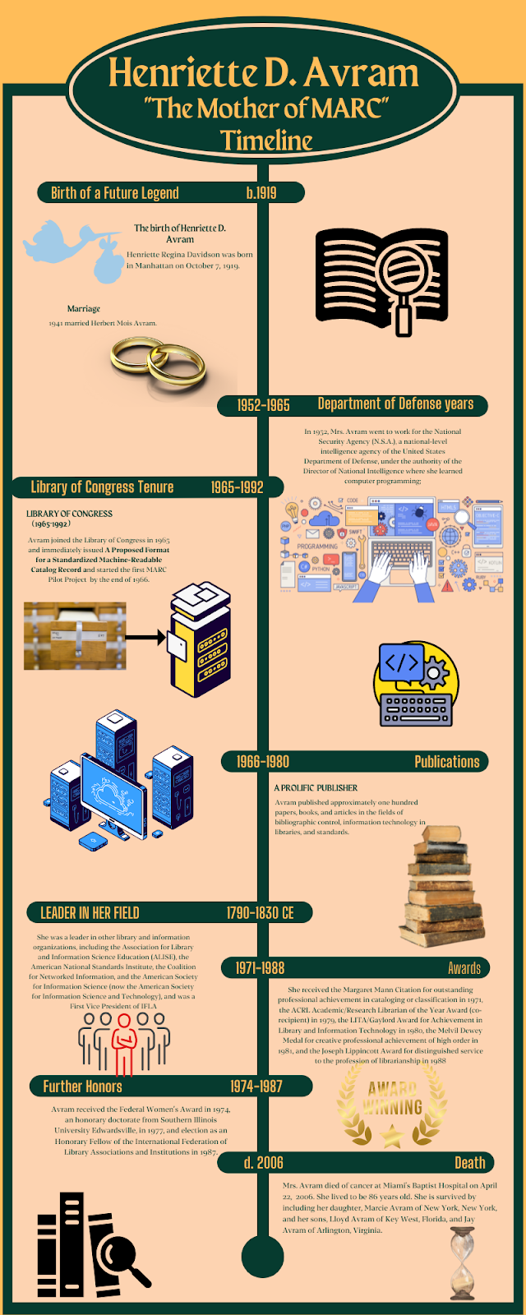](https://www.canva.com/design/DAFR_bI1vg8/dyIwVEFkZaJ6ohQbwBo4FQ/edit?utm_content=DAFR_bI1vg8&utm_campaign=designshare&utm_medium=link2&utm_source=sharebutton)