SWOT Analysis

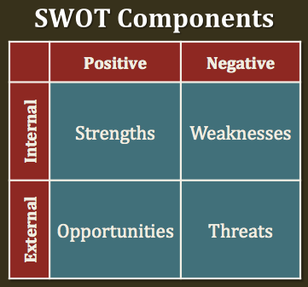

A SWOT is an analysis of the Strengths, Weaknesses, Opportunities, and Threats to an organization or entity. In this case, the entity is educational technology at our school. Please keep in mind that Strengths and Weaknesses are internal--things which we control within our program. Opportunities and Threats are external or outside of our control.

**Strengths:** Resources and capabilities that can be used for developing a competitive advantage.

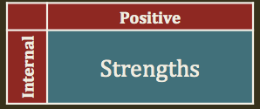**Guiding Questions:**

* What are the department’s advantages?
* What does the department do well?
* What relevant resources do you have access to?
* What do other people see as your strengths?
* What would you want to boast about to someone who knows nothing about this organization and its work?

**STRENGTHS** of educational technology at Humble ISD:

Strong technology department

Teachers receptive to learning new things

Academic and administrative support

Technology resources and tools

Public access to resources online

Technology Maintenance

They have a **reasonable district/school technology department** compared to other Texas ISDs

They have a decent adequate, organized, and considerable technology department with resources and support that is publicly available.

They have **access to district/school technology support**

**Teachers** are receptive to learning new things

**Weaknesses:** Internal force that could serve as a barrier to maintain or achieve a competitive advantage; a limitation, fault or defect; OR absence of certain strengths.

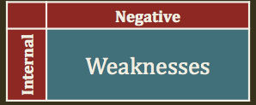**Guiding Questions:**

* What can be improved?
* What is done poorly?
* What should be avoided?
* What are you doing as an organization that you feel could be done more effectively/efficiently?
* If you could change one thing that would help this department function more effectively, what would you change?

**WEAKNESSES** of educational technology at Humble ISD:

Professional development / technology training

Tech savvy

Bandwidth

Time

Time in the day/weeks for faculty to take on incorporating new technologies into their curriculum and pedagogy because they are currently not having enough time in the day/weeks to do their day-to-day duties and commitments.

technology training for faculty and students

Although they do have a detailed professional development plan available online as well, this plan didn’t mention anything about technology training for faculty and students, which would be essential.

incorporate the professional development and technology plans

Although they also have available online a technology plan that does include implementing technology professional learning, it would be a great idea to incorporate the professional development and technology plans so that faculty, students, and staff could draw from areas of needed professional/technology trainings from the same place.

technology resources visible and easily accessible

I would include advertised areas of technology integration professional development within the school/district so that faculty, staff, and students would have such important technology resources visible and easily accessible.

I would have teachers and technology department actively collaborate to determine more ways that technology can be incorporated into the active learning environments in the schools and classrooms.

From the hearty public website, they could list the ways in which they support the district/schools with technology (although I did notice they had a detailed curriculum technology integration plan available online).

**Opportunities:** Any favorable situation present now or in the future in the external environment; Or new external opportunities for profit and/or growth.



**Guiding Questions:**

* What are the good opportunities facing you?
* What are the interesting trends you are aware of?

**OPPORTUNITIES** of educational technology at Humble ISD:

COVID-19

COVID-19 can be viewed as an opportunity for educational technology because it served as a catalyst for schools/districts to quickly continue teaching and learning with minimal interruptions in academics once everyone was required to quarantine until a vaccine could be developed to use to contribute to combatting this awful and deadly virus.

Nontraditional online learning; Non-traditional online learning growing

Technology skills

Faculty and staff began working remotely and are learning new skills including virtual communication and virtual team meetings with each other and students….

Professional development / technology training

Publishers and technology companies offering technology training to faculty who use their product in the classrooms....

Due to recent ongoing pandemic, schools now have opportunities to have fewer snow days because of the ability of students, staff, and educators to continue schoolwork expectations virtually in the event of inclement weather

**Threats:** External force that could inhibit a competitive advantage; any unfavorable situation in the external environment that is potentially damaging.

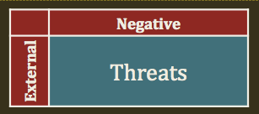**Guiding Questions:**

* What obstacles do you face?
* What is your competition doing?
* Are the required specifications for your job/services changing?
* Is changing technology threatening your position?
* Do you have financial problems?
* Could any of your weaknesses seriously threaten your department?

**THREATS** of educational technology at Humble ISD:

Outside competition

COVID-19

Economic burdens

Parental distractions

Economic uncertainty

There has been significant increase in schools/districts and other academic institutions competing for students

Due to ongoing COVID-19 quarantining and students and teachers being separated, students have fewer overall optimal learning experiences because of being in less controlled home learning environments.

Economic burdens for parents of younger children who now have to change the ways of childcare under such circumstances of the current ongoing pandemic.

Parents face distractions with their shared remote work environments that are now being shared with their children learning virtually at home that the parents are now at home facing which is less than ideal.

General economic uncertainty that is now unfolding due to the COVID-19 pandemic

Due to recent ongoing pandemic, schools now have threat to have continued additional snow days because of the possibilities of students, staff, and educators to be prevented from schoolwork expectations virtually in the event of inclement weather due to lack of the internet, power, and safety in such extreme events as in recent years.

Some schools and higher education academic institutions restructuring from education to corporate model of institutions, which leaves insecurities and lots of uncertainties where educators and student-centered priorities are concerned.

Technology changes, at times and is too fast for academic institutions to keep up