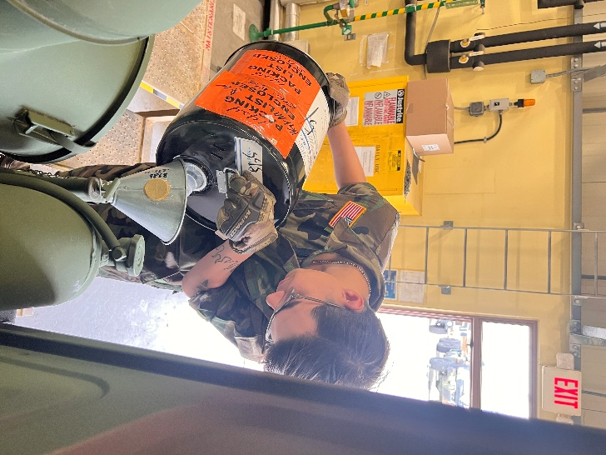

LEAD-540 Manage Projects Work

Professor Roger Buskill

Culminating Undergraduate HAT

Project mAINTENANCE - Organizational Needs Assessment

February 2,2025

Encarnacion Hernandez

Table of Contents

Description of the Project 2

Scope Statement 3

Stakeholder Analysis 4

Business Case for Project Tomahawk 5

# Description of the Project

Project title: Project Maintenance – Organizational Needs Assessment

Project description:

The mission of Project Maintenance is to conduct a needs assessment project for the 95th Transportation fuel company, a U.S. Army unit stationed in South Korea. The company is currently facing a problem with maintenance service packets being completed incorrectly for military equipment. The most common reason for the service packets being completed incorrect is because the operators of the equipment are completing the *Equipment Maintenance & Inspection Worksheet* also known as DA FORM 5988-E. This is resulting in faults with vehicles not being annotated correctly which can lead to further damage to the company’s vehicle if not addressed properly. The needs assessment project will help identify factors that is causing this issue and identify possible solutions to fix the problem.

# Scope Statement

|  |
| --- |
| **Project Title: Project Maintenance - Organizational Needs Assessment**  **Date: 2 February 2025** **Prepared by:** Encarnacion Hernandez |
| **Project Justification:**  Project Tomahawk aims to support the 95th Transportation Fuel Company by conducting a needs assessment to help identify the problem with service packets and DA Forms 5988-E. Soldiers assigned as vehicle operators are completing service packets and filling the Equipment Maintenance & Inspection Worksheet (DA FORM 5988-E) incorrectly. This is resulting in faults of vehicles not being annotated correctly which leads to further damage to vehicles if not addressed properly. The needs assessment project will help identify factors that are causing this issue and identify possible solutions to fix the problem. The needs assessment project will help identify factors that are causing this issue and identify possible solutions to fix the problem. |
| **Product Characteristics and Requirements:**   1. Conduct external and internal organizational scan 2. Determine the status of operations and analyze business needs 3. Identify training products and soldier experience 4. Deliver organizational needs assessment with suggestions |
| **Product User Acceptance Criteria:**  Provide a detailed report that addresses the current state of the company’s Preventive Maintenance Checks and Services (PMCS) procedures. Analyze the training process to identify deficiencies. Indicate suggestions for training new soldiers on how to correctly fill out DA Form 5988-E.  **Summary of Project Deliverables**  **Product-related deliverables:**   1. Maintenance Service Coversheet 2. PMCS and DA Form 5988-E Class |

# Stakeholder Analysis

|  |  |  |  |
| --- | --- | --- | --- |
|  | **Key Stakeholders** | | |
| **Stakeholder 1** | **Stakeholder 2** | **Stakeholder 3** |
| **Organization** | Phi H. Phan | Encarnacion Hernandez | Ricardo Rivas |
| **Role on Project** | Project Sponsor | Project Manager | Supplier |
| **Unique facts about stakeholder** | Motor Sergeant for the company’s maintenance section | Experienced in Command Maintenance Discipline Program (CMDP) and Preventive Maintenance Checks and Services (PMCS) | Provides resources for the project |
| **Level of Interest** | Project Success, way ahead for future | Accurate Data pulled, Completion | Fulfillment of contract |
| **Level of influence** | High | High | High |
| **Suggestions on managing relationships** | Daily updates, meeting scheduling | Detailed daily reports | Daily communications to ensure delivery of resources |

# Business Case for Project Maintenance

**February 2, 2025**

**Project Name: Project Maintenance**

|  |
| --- |
| 1. **Introduction/ Background**   The 95th Transportation Fuel Company part of the 498th Combat Sustainment Support Battalion is a U.S. Army unit stationed in South Korea. The Company’s mission is to provide bulk fuel to military units located in the southern region of South Korea. There is a problem with soldiers incorrectly completing maintenance service packets and DA Forms 5988-E. This is resulting in faults of vehicles not being annotated correctly which can lead to further damage to the company’s vehicle if not addressed properly. If this issue continues the company’s equipment readiness will be negatively impacted and may compromise their mission of providing bulk fuel. Project Maintenance has been retained to do an in-depth analysis of the current standing of the company, recommendations to maintenance service program may be necessary to maintain a competitive edge while striving to continue their mission of providing bulk fuel. |
| **2.0 Business Objective**  Upon a thorough evaluation of maintenance service packets, and DA Form 5988-E, we will be recommending an upgrade to the maintenance training to that which is more efficient. Our goal is to create training that will be easy to understand for the vehicle operators. The training will ensure that the company’s soldiers understand how to properly Conduct Preventive Maintenance Checks and Services (PMCS) and for to complete and process an Equipment Maintenance & Inspection Worksheet also known as DA Form 5988-E. |
| **3.0 Current Situation and Problem/Opportunity Statement**  As data is currently being processed for review, it is crucial that we continue to move forward in our research into improving maintenance service packets and DA Form 5988-E process flow. We will be doing an internal audit of maintenance service packets of equipment and DA Form 5988-E that have were processed incorrectly. Incentives like promotions will be offered to those who volunteer to be an instructor and implement the new maintenance training effectively. |
| **4.0 Critical Assumption and Constraints**  Cooperation from leaders and soldiers is crucial during this time; we have requested maintenance service packets and DA Form 5988-E within the company from 2020-current. In addition, we have conducted interview with soldiers to identify the challenges that they face while completing DA Form 5988-E. An inspection of all Preventive Maintenance Checks and Services (PMCS) technical manuals is recommended to evaluate the necessity and viability of any out-of-date publications. |
| **5.0 Analysis of Options and Recommendation**  Upon receiving all requested documentation, maintenance service packets, publication inspections, previous maintenance training record, we would like to have you first consider some options ahead of time. With a deadline of April 2025 commencing the change in process flow is important to be proactive in keeping all stakeholders informed. Communication is of the utmost importance to facilitate a smooth transition with positive outcomes for all involved. |
| **6.0 Preliminary Project Requirements**  Requirements for the success of this project will consist of the following:   1. Analysis of each maintenance sercive packet for each peace of equipment. 2. Feasible Study to determine the knowledge that Soldiers within the company possess. 3. Explore diverse ways to create a Preventive Maintenance Checks and Services (PMCS) training to make it easy and interactive. 4. Research for updated technical manuals. 5. Identify the best candidates to fulfill assistant intructor roles. |
| **7.0 Schedule Estimate**  This project is expected to reach completion within 2 months. The first month will include the consolidation and re-organization of maintenance service packets. The second month will be the launch of innovative maintenance services and DA Form 5988-E flow training. |
| **8.0 Potential Risks**   1. Company unable to accomplish their mission due to interruption of real-world missions. 2. Finding innovative training methods that will keep soldiers engaged. 3. Resourcing update technical manuals to complete DA Form 5988-E to standard. |