Data-driven decision making for student learning outcomes at Kobe Academy

Evaluation of Common Core Standards using MAP data over 2 years (2021/2022) for Grades 3, 4, and 5

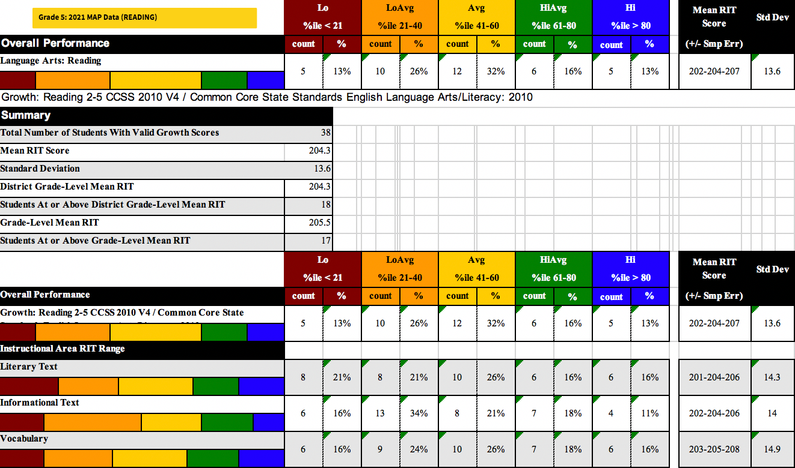

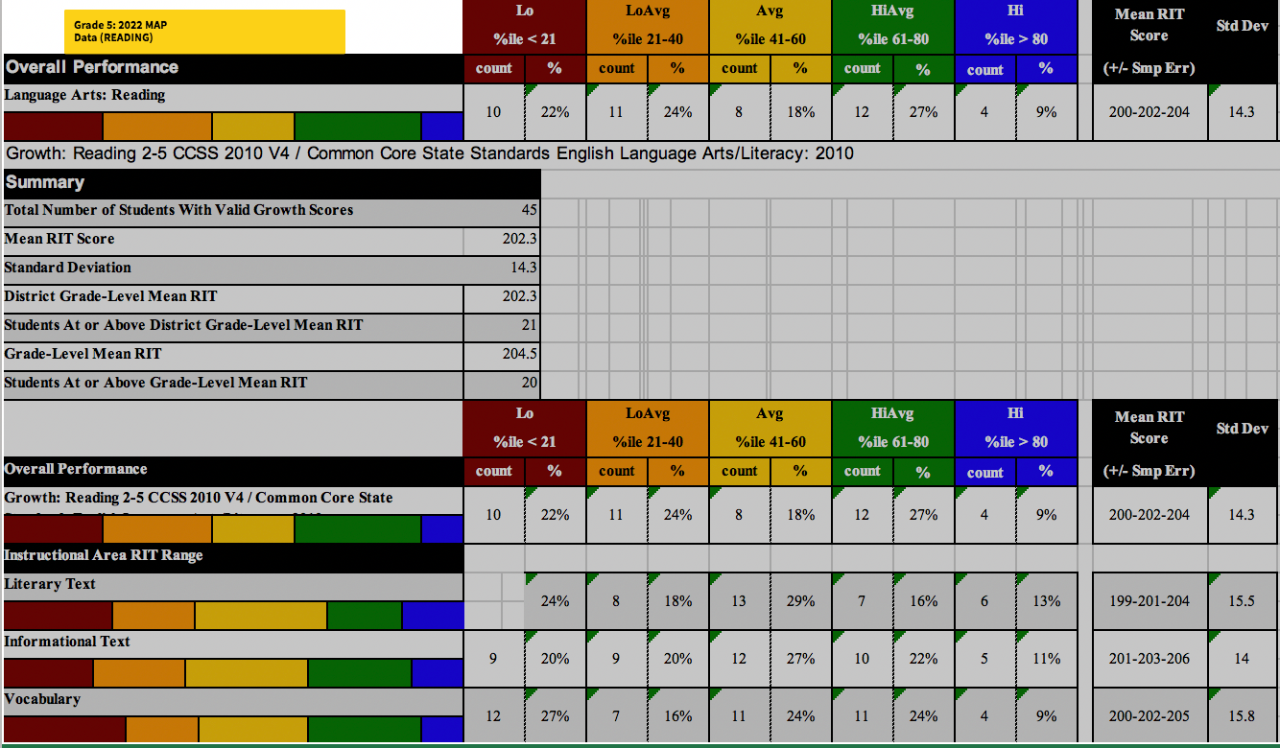

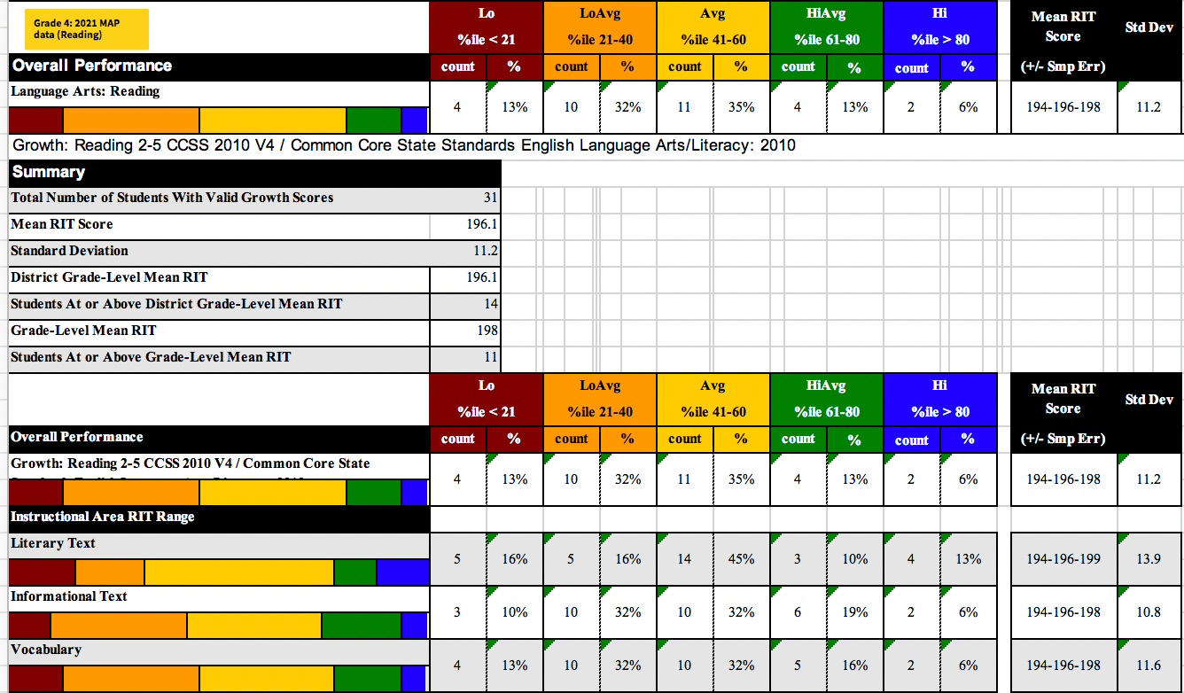

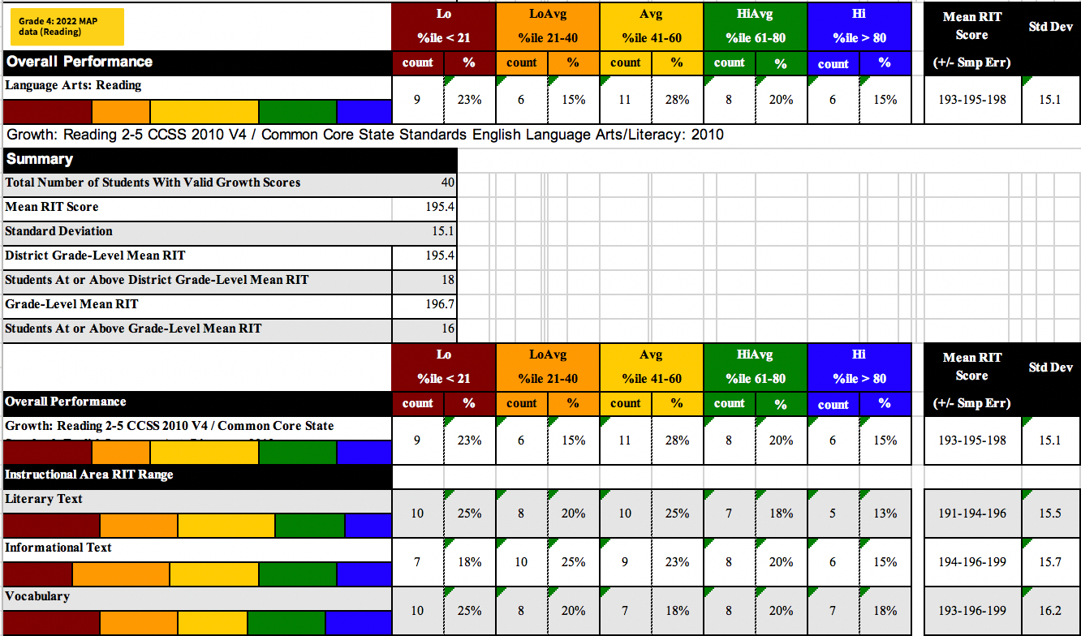

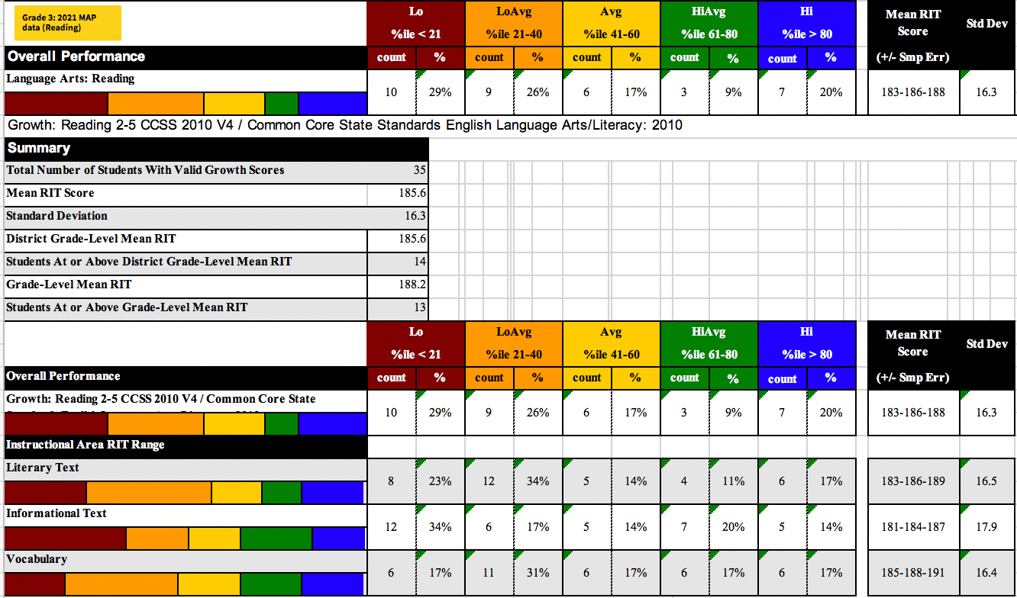

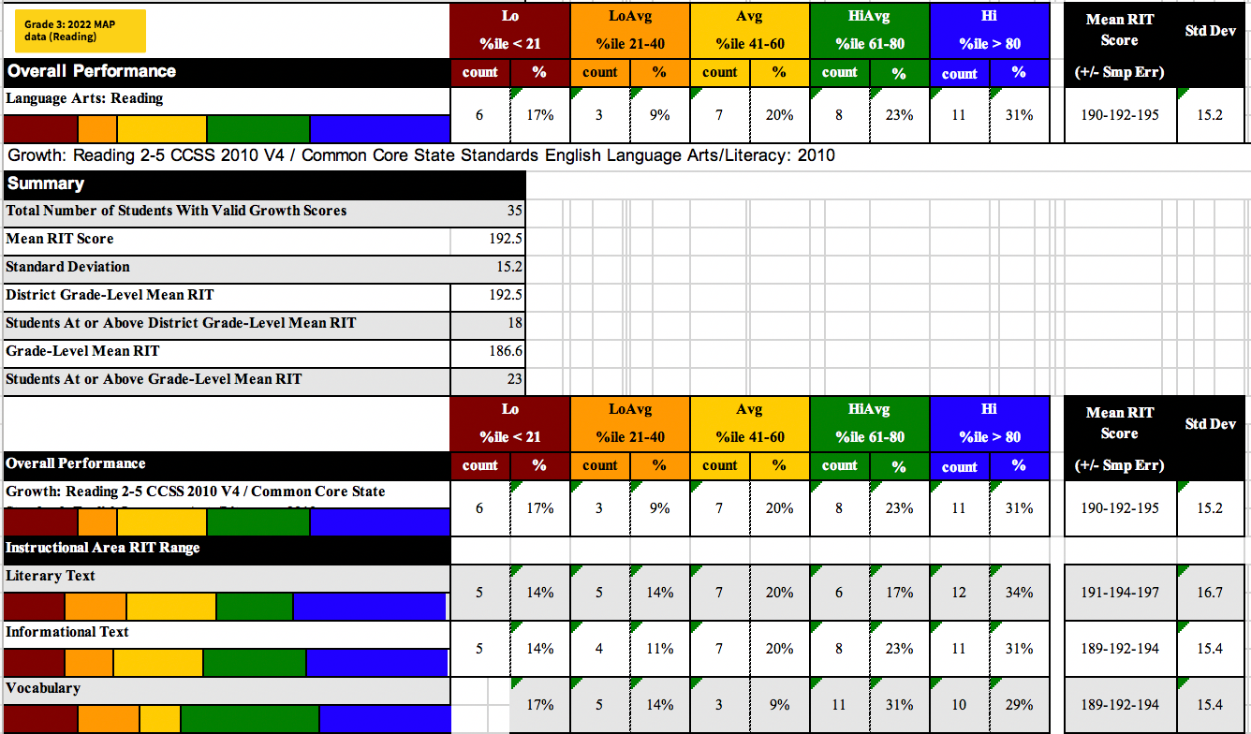

Data-led decision making for student driven learning at Kobe Academy

Kobe Academy is going to extensively review its literacy programs and the correlating impacts on improving reading using Measures of Academic Progress (MAP) data over the course of two years. These MAP data are derived from a computer adaptive test used to measure a student's academic growth and achievement in the areas of math, reading, and language usage. It is designed to assess what students know and are ready to learn, and to provide teachers with data to inform instruction. The focus here is on the Reading data because based on our demographics, the school has a high EAL population. These are areas where students struggle overall the most based on these data. There is a prescient need to improve so students can access the curriculum quickly. Grades 3, 4, and 5 at Kobe Academy are composed of almost 40% EAL (English as an additional language) students. Students hailing from 32 different countries are represented at Kobe Academy. Students’ primary passport determines their main nationality. Students carrying more than one passport are noted as multicultural. Due to the diversity of our student population, a majority of the students have English as a second language and may require differentiation or additional language support in the classroom.

The MAP test is administered to students in grades K-12 and is usually taken three times a year: fall, winter, and spring. The test is adaptive, meaning that the difficulty level of the questions adjusts based on the student's responses. If a student answers a question correctly, the next question will be more challenging. If a student answers a question incorrectly, the next question will be easier. This way, the test can hone in on a student's ability level with precision.

The MAP test provides teachers and administrators with a detailed report of a student's performance in various areas, including their overall score, their progress over time, their strengths, and areas where they may need additional support. This data can be used to inform instruction and provide targeted interventions to help students improve their academic performance.

Kobe Academy is using Common Core ELA standards (English literary arts). One of the tests depicted here is the NWEA MAP tests for reading growth (other test measures include: running records, WIDA, and Fountas & Pinnell in addition to internal report card data ). My focus is on the MAP data (standardized testing) and all of the MAP areas directly connect to Common Core standards. The Kobe Academy standards and campus-wide goals are directly tied to using the [Common Core](https://learning.ccsso.org/wp-content/uploads/2022/11/ELA_Standards1.pdf). The following are some  Common Core Reading Standards by grades represented in the data:

Grade 3:

* Ask and answer questions to demonstrate understanding of a text, referring explicitly to the text as the basis for the answers.
* Determine the main idea of a text and explain how it is supported by key details.
* Describe characters in a story (e.g., their traits, motivations, or feelings) and explain how their actions contribute to the sequence of events.

Grade 4:

* Refer to details and examples in a text when explaining what the text says explicitly and when drawing inferences from the text.
* Determine the meaning of words and phrases as they are used in a text, including those that allude to significant characters found in mythology.

Grade 5:

* Quote accurately from a text when explaining what the text says explicitly and when drawing inferences from the text.
* Determine the meaning of words and phrases as they are used in a text, including figurative language such as metaphors and similes.
* Compare and contrast stories in the same genre (e.g., mysteries and adventure stories) on their approaches to similar themes and topics.

For the student learning assessment, I will be focusing on the Common Core Reading standards for Grade 5 driven by the MAP testing data which showed Low-Low/Average understanding of core Reading. As discussed above, students need to improve their Reading so that they can access the curriculum quickly, especially as they transition to Middle School. The lesson plan will be focused on Reading, specifically determining the meaning of Vocabulary in complex texts.

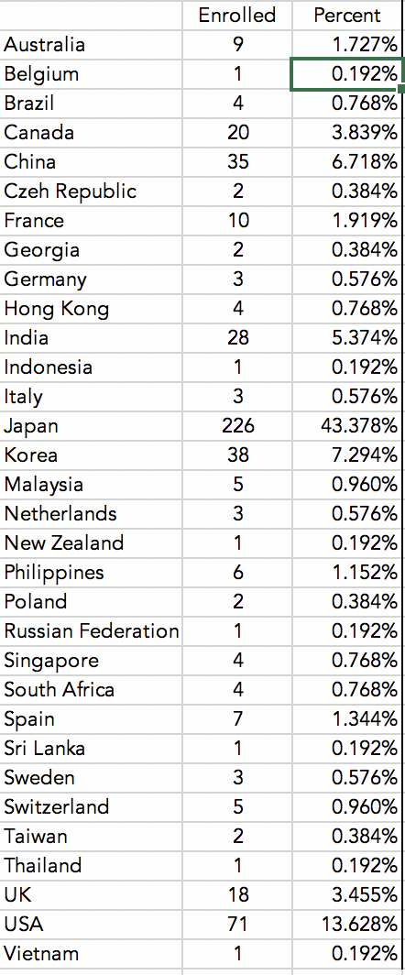

**Kobe Academy Demographic Breakdown**

Chart Legend/Results Table Legend for MAP Testing

|  |
| --- |
| 1: **Student RIT** – The student’s RIT score on each growth test. |
| 2: **District Grade Level Mean RIT** – The average RIT score for students in the same  school district and same grade that were tested at the same time as the student named on this report. Lack of the District Grade Level Mean RIT bar indicates that the RIT is not available due to the district testing window not being closed. |
| 3: **Norm Grade Level Mean RIT** – The average RIT score for students in the same  grade and tested in the same term as observed in the most recent NWEA RIT Scale  Norms study. Lack of the Norm Grade Level Mean RIT bar indicates that the RIT is not available due to no norm data being available for that particular grade and/or subject. |
| 4: **Student RIT Projection** – The projected RIT score of the student for when they take a future test. This projected RIT score is based on the student’s actual RIT score in the first term of the Growth Comparison Period and the average RIT growth of students who were in the same grade and tested in the same term as observed in the most recent NWEA RIT Scale Norms* study. |
| 5: **Goals Performance** – Each goal area included in the test is listed along with a goal range or descriptive adjective of the student's score. The possible descriptors are Low (percentile < 21), LoAvg (percentile between 21 and 40), Avg (percentile between 41 and 60), HiAvg (percentile between 61 and 80), and High (percentile > 80). An asterisk (*) is displayed if the goal score was not able to be calculated due to too many items answered incorrectly or too few items available in the RIT range assessed. |
| 6: **Lexile® Range** – This range appears when the student has taken a reading test.  You can use it with online resources to identify appropriately challenging books,  periodicals, and other reading material for the student. Lexile® is a trademark of  MetaMetrics, Inc. |
| 7: **Growth Comparison Period** – The terms that define the time frame for which  the RIT Growth, Growth Projection and Student RIT Projection value(s) are  calculated. |
| 8: **Term/Year** – The test term (FA=fall, SP=spring, WI=winter, SU=summer) and  the year when the student took the test. |
| 9: **Grade** – Grade of the student when the test was taken. |
| 10: **RIT** – The middle number is this student's RIT score. The numbers on either  side of the RIT score define the score +/- the standard error. If retested soon, the  student's score would fall within this range most of the time. |
| 11: **RIT Growth** – Presents the student’s growth in RIT points made between  growth tests in the Growth Comparison Period. |
| 12: **Growth Projection** – The average growth of students who were in the same  grade and began the same term at a similar RIT score according to the most  recent NWEA RIT Scale Norms* study. |
| 13: **Percentile Range** – The number in the middle is this student's percentile  rank, or the percentage of students that had a RIT score less than or equal to this  student's score according to the most recent NWEA RIT Scale Norms study. The  numbers on either side of the percentile rank define the percentile range. If  retested soon, this student's percentile rank would be within this range most of  the time. |
| 14: **Non-growth tests** – Tests may be taken from time to time for informational  purposes only and are not used to determine student growth. These tests are  presented in gray italicized text. |