

Procurement Management Process ©
For Aircraft RD Seven

Document Control

Document Information
© | Information
Document Id | RD-121121-11
Document Owner | Marc McCune
Issue Date | March 09, 2013
Last Saved Date | March 09, 2013
File Name | PMGT690 Capstone\3 Executing\Artifacts\Dump\Ina-Prcs\Aircraft RD Seven Project Procure Control.docx

Document History
Version | Issue Date | Changes
Initial Release | March 09, 2013 | Initial Release

Document Approvals
Role | Name | Signature© | Date
Project Sponsor | Mr. Joe Rocket |  | March 09, 2013
Project Review Group | Mr. Marc McCune |  | March 09, 2013
Project Manager© | Mr. John Headly |  | March 09, 2013
Quality Manager | Ms. Joan Smith |  | March 09, 2013
Procurement Manager | Ms. Sally Parks |  | March 09, 2013
Communications Manager | Ms. Heather Plinkton |  | March 09, 2013
Project Office Manager | Marc McCune |  | March 09, 2013

Table of Contents

Template Guide 1
1 Procurement Process 2
1.1 Overview 2
1.2 Issue Purchase Order 3
1.2.1 Identify Required Product 3
1.2.2 Document Purchase Order 4
1.2.3 Approve Purchase Order 4
1.2.4 Issue Purchase Order to Supplier 4
1.2.5 Communicate Delivery Timeframes 4
1.3 Fulfil Purchase Order 4
1.3.1 Receive Product 4
1.3.2 Review Product 5
1.3.3 Resolve Product Issues 5
1.3.4 Accept Product 5
1.3.5 Approve Payment 5
1.4 Manage Supplier Contract 5
1.4.1 Confirm Milestone Reached 5
1.4.2 Review Supplier Performance 5
1.4.3 Identify Supplier Issues 6
1.4.4 Resolve Supplier Issues 6
1.4.5 Communicate Review Outcome 6
2 Procurement Roles 6
2.1 Procurement Manager / Officer 6
2.2 Project Manager 6
3 Procurement Documents 7
3.1 Procurement Register 7
3.2 Purchase Order Form 7

Procurement Process

Overview

The Procurement Management Process is utilized to obtain all applicable resources for the project including raw materials, components, asset resources, and labor ©

The Procurement Plan identifies the products, suppliers, and schedule specific to this project. The Purchase Order is the primary instrument identifying the goods required and specifies required by information, specifications for the goods, and RD Aircraft acceptance criteria.

Purchase Orders are approved by the Procurements Director, or designee with all transactions recorded within the computer purchase order system.

Procurement Management is responsible to this project for the implementation of three key processes:

- The issuing of Purchase Orders
- The completion of Purchase Orders
- The management of supplier contracts. ©

See the diagram on the next page identifying the requirements to manage effectively the procurement of products from suppliers for the project.

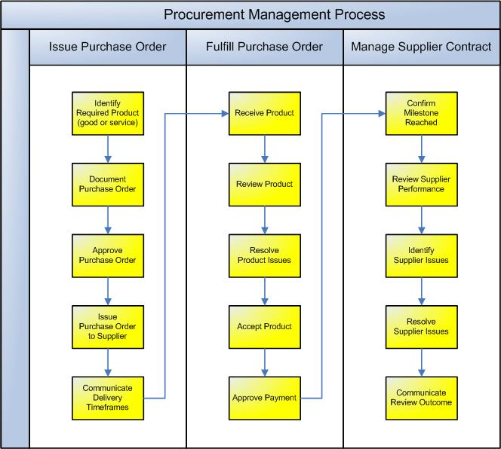

Issue Purchase Order

The first process required to purchase product from an external supplier is the creation and issue of a Purchase Order. The following procedures are undertaken:

    - Identify Required Product
Operations request the goods to be ordered identifying the specification of the goods, the time needed, and any special requirements in the computer purchase order system.

    - Document Purchase Order
Procurement personnel will identify the order in the computer purchase order system and select an appropriate supplier for the request based on available suppliers in the computer purchase order system database. If no suppliers meet the criteria for the goods, Quality Engineering will assist in the selection of an appropriate supplier.

    - Approve Purchase Order
The Purchase Order is then forwarded to the appropriate individual depending on the following schedule:

Purchase Amount in Dollars US | Approval Level*
Above $200,000 | CEO of RD Aircraft
$199,000 - $50,000 | Project Manager
$49,000 - $5,000 | Procurement Manager
Below $4,999 | Requesting Operations Manager

* Note: The computer purchase order system automatically restricts purchase order approval based on the authority set for individuals in each approval level.

The following criteria prior will be determined before submitting the purchase order for approval:

- Is the product listed within the specification or build of material?
- Is the supplier approved to receive the data to supply the product, (confidentiality agreements, International Traffic in Arms Regulations, (ITAR) restrictions, etc.))?
- Is time quoted by the supplier consistent with time required by existing milestone charts for the project?
- Is the supplier listed in the approved supplier database within computer purchase order system? ©

    - Issue Purchase Order to Supplier
Once the appropriate individual approves the Purchase Order, it is issued to the supplier for action by electronic transmittal.

    - Communicate Delivery Timeframes
The Supplier then confirms receipt of the Purchase.

Fulfill Purchase Order
The supplier then processes the Purchase Order and the product delivered to the project as ordered. Quality Control Receiving Inspection then reviews the product, identifies, and resolves any product issues. The product is then formally accepted and supplier payment is authorized. The following procedures are undertaken: ©

    - Receive Product
The supplier fulfils the order by delivering the product (as defined by the Purchase Order) to the Project. Quality Control Receiving Inspection physically views the product received and confirms that the project team have received it into their care. In the case of a service delivered by the supplier, the Procurement Manager confirms from the project team that the service has been performed and is ready for review. Bulk shipments can be randomly inspected as established by Quality Engineering. Items rejected will be held in a quarantine area until the issue is resolved.
    - Review Product
The product is then inspected / reviewed to access whether it meets the requirements of the initial Purchase Order. This may involve a physical inspection (in the case of a ‘good’) or audits (in the case of a ‘service’) to determine that the product was delivered on time, within cost and at the level of quality required.

    - Resolve Product Issues
If the outcome of the review is that one or many of the requirements set out by the Purchase Order have not been satisfactorily achieved, then the Procurement Manager raises a formal Issue. The extent of the problem is then quantified and the impact and severity of the issue rated. The Project Manager will then lead the resolution of the issue to ensure that it is quickly and appropriately resolved. © Items rejected will be held in a quarantine area until the issue is resolved so as not to allow it into the operations environment.

    - Accept Product
Once all product delivery issues have been resolved, the Quality Control may formally accept the product on behalf of the project team and the Procurement Manager will notify the supplier.

    - Approve Payment
The supplier will then send the project team an invoice, which is approved for payment by the appropriate individuals identified in paragraph 1.2.3, (given no current outstanding issues).

Manage Supplier Contract
The above procedures are undertaken for each Purchase Order issued by the project. In parallel to the procurement of product for the project, the overall performance of the supplier must regularly be assessed to determine that s/he is fulfilling the overall conditions of the contract. This process involves reviewing the supplier's performance and ensuring that all contractual conditions are being met throughout the project.

    - Confirm Milestone Reached
During the Planning phase, a number of supplier review milestones will have been identified and documented (as part of the Procurement Plan). Each review milestone may be triggered by the completion of a particular project phase, deliverable or date. Once each milestone is reached, the Procurement Manager informs the Project Manager that the supplier's performance is ready to be assessed and a formal assessment program is initiated. ©

    - Review Supplier Performance
The Procurement Manager leads a review of the supplier's performance. This may involve:
- Confirming that the review milestone has been reached
- Listing the actual products provided by the supplier and identifying whether or not they met the requirements of the purchase order and what impact there was on any delivery issues that arose
- Confirming that each condition listed within the supplier contract was met as specified.

Quality Engineering audits suppliers for compliance to a Quality system that is the equivalent of RD Aircraft and that the supplier can satisfy certain special requirements such as providing return to service for work performed per Federal Aviation Administration requirements.

The computer purchase order system collects this information and statistical data is analyzed by Quality Engineering.

    - Identify Supplier Issues
Any issues identified during the supplier performance review are listed and the overall impact on the ability of the project to achieve its objectives is quantified. A formal supplier issue is then documented and raised with the Project Manager for resolution. This is recorded and coded in the computer purchase order system. Data is utilized from the computer purchase order system to track supplier performance and trends.

    - Resolve Supplier Issues
The Project manager then leads the resolution of each issue identified through negotiation with the supplier. The following outcomes may occur:

- The supplier is allowed to continue supplying to RD Aircraft.
- The supplier is informed that should further issues occur, then payment will be withheld and the contract potentially terminated
- Supplier payment is withheld and/or the contract terminated. Either the Project Manager or the Supplier may commence legal action. ©

    - Communicate Review Outcome
Once the supplier performance review is completed and any issues resolved, the outcome of the review is communicated to key project stakeholders (e.g. the Project Sponsor). Data metrics are available within RD Aircraft computer network system.

Procurement Roles
Define the roles and responsibilities for all resources (both internal and external to the project) involved with the procurement of product and management of supplier relationships. Examples include:

Procurement Manager / Officer
The Procurement Manager (or Officer) is responsible for ensuring that the entire Procurement Management process is executed appropriately, including:

- Documenting each Purchase Order and forwarding it to the appropriate individual listed in paragraph 1.2.3 for approval.
- Issuing the Purchase Order and communicating the delivery timeframes.
- Identifying and resolving any product delivery issues.
- Accepting the product and requesting supplier payment from the appropriate individual listed in paragraph 1.2.3.

Project Manager
The Project Manager acts as a checkpoint to ensure that the Procurement Management Process is being undertaken properly by:

- Ensuring supplier contractual issues are resolved and agreeing a formal outcome.

Procurement Documents

Articles accepted by Quality Control Receiving Inspection will bear either the stamp of the inspector or the electronic signature in the appropriate individual listed in paragraph 1.2.3.

Items with a shelf life will be identified within the computer purchase order system.

Rejected parts will be quarantined and bear a red tag, RD Aircraft form NG-221.

Procurement Register
The ‘Procurement Register’ is the log / database where all Purchase Orders are registered and tracked through to approval. A sample computer output is displayed below:

Supplier | Supplier Code | Approved for | Limitations | Next Audit Due
Joes Brackets | A152 | Machine parts/ fabrication | None | Jan. 3, 2014
Francis Electrical | F354 | Manufacture electrical components | ITAR | Oct. 21, 2012

Purchase Order Form
The ‘Purchase Order Form’ is used to request the delivery of product by an external supplier to the project and is contained within the computer purchase order system.

