**Presenter’s Guide to *DegreeWorks***

**Presenter**

**What is a Degree Audit? What is *DegreeWorks*?**

A **degree audit** is an analysis that enables the student and his/her advisor to assess the student's academic progress and unfulfilled certificate or degree requirements. In other words, it lets one know where one is at in relation to the “finish line.” *DegreeWorks* automates the audit process and serves as a graduation self-check resource, allowing students to be more participatory in their college experience and promoting self-advocacy.

**History of *DegreeWorks***

1. Aims bought *DegreeWorks* to automate a process. Until *DegreeWorks* was used, finding out where a student was in terms of certificate or degree completion was done by hand using a printed certificate or degree worksheet.
2. It was hoped that the “Planner” feature of *DegreeWorks* would allow departments to project course demand, but the Planner feature didn’t really take off as there were some software shortcomings. While the planner feature has improved with recent software updates, the project may be on hold as other emerging software possibilities are considered.

**Student – Getting to myAims Login**

Go to the Aims home page at [www.aims.edu](http://www.aims.edu). **Click in the upper right-hand corner on *myaims login*.**



**Student – myAims Login Page**

On the login page, **enter your myAims username and password and press the red *LOGIN* button**.

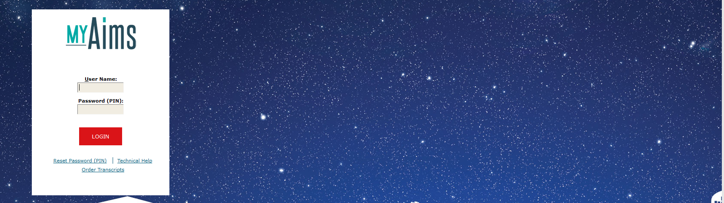

**Student – Finding *Student* Tab**

Your login view defaults to the content under the *My Campus* tab. **Click the tab marked *STUDENT*.**

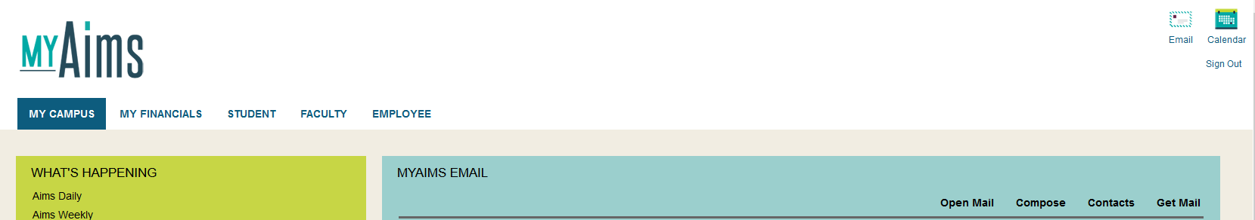

**Student – Finding the *DegreeWorks* Link**

**Find the blue box titled *ADVISING*.** In that box, **click on *DegreeWorks (Graduation Self-Check)***. Your *DegreeWorks* content will automatically load.



**Student – Reviewing Student View Info. and Progress Bar**

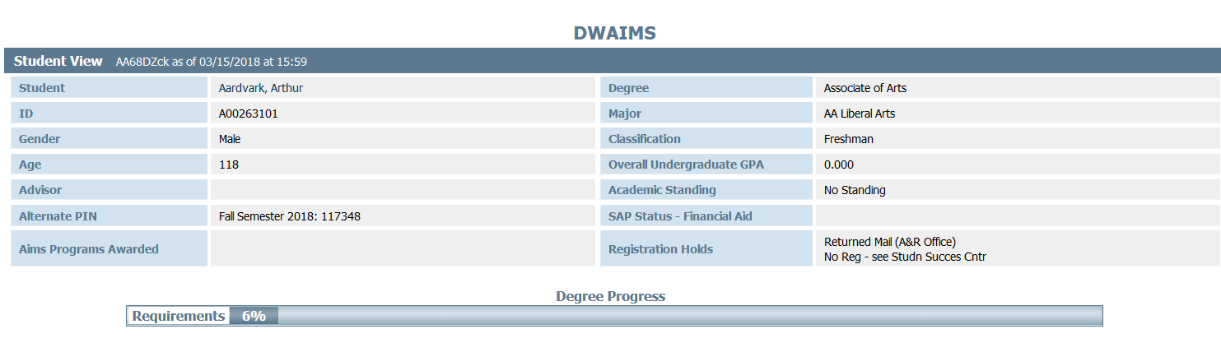

**Review** **the *Student View* information at the top of the *DegreeWorks* page** **and the progress bar and answer the following questions:**

What is your Aims ID number? _________________________________________________________________________

What is your declared degree? _________________________________________________________________________

What is your declared major? __________________________________________________________________________

What is your overall undergraduate GPA? _______________________________________________________________

What is your academic standing? _______________________________________________________________________

What is your SAP (Satisfactory Academic Progress) status? __________________________________________________

List any holds you have. ______________________________________________________________________________

What percentage of your certificate or degree requirements will you have completed by semester’s end? ____________

**Student – Reading Cert./Degree Header / Academic Year Info.**

**Read the certificate or degree information** leading up to the actual course requirements for your degree.

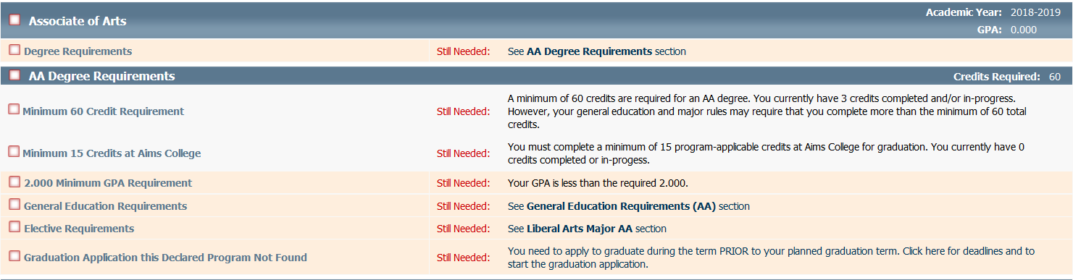

Under what ***Academic* *Year’s*** (or “Catalog Year’s”) requirements will you graduate? _____________________________

**Student – Reviewing Course Information**

□ **Scroll down to view the course requirements for your declared major.** Not counting your current courses, how

many courses do you need to complete to earn your certificate or degree? _________________________________

□ **See the courses you are enrolled into for this semester. See classes you may have already completed, withdrawn**

**from, or transferred in from another college or university. Scroll down even farther to see classes displayed as *In***

***Progress* and/or *Not Applicable to Program*. Notice the different symbols and colors used to help you interpret**

**your Audit, which helps you track your progress to completing your certificate or degree.**

Notes/Questions: ___________________________________________________________________________________

__________________________________________________________________________________________________

**\* [See related presenter notes on following pages.]**

**\* Presenter: Course Status Legend**

* **Completed Course: Green box with check mark and the whole line will turn yellow. Also displayed on the line is the grade received in the course, the course credit value, and in what term the course was completed.**

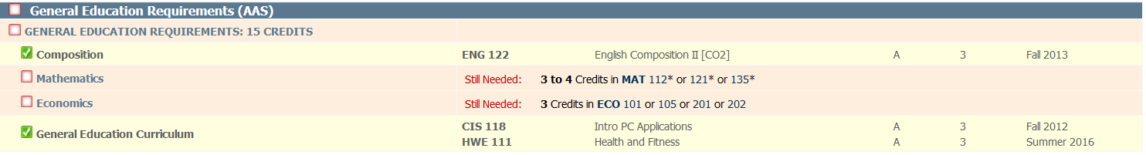

* **Completed Category: All course boxes green with check mark. The “category” box also turns green with a checkmark, and the category line turns yellow.**



* **Not Yet Completed: Course and/or category box empty with red outline, and whole line is peach color.**



* **Complete Except for Class(es) in Session: Blue box with white wavy line indicates a course that is in session and/or that all requirements in a category are complete except for class(es) in session that term. Whole line is blue.**



**Student – Using *Class History* Link / *GPA Tracker***

□ **Investigate the *Class History* link near the top of the page. You can see the classes taken by term, much like**

**viewing an unofficial transcript. Be certain to scroll all the way down the resulting page to see the *GPA Tracker*.**

**\* [See related presenter notes below.]**



Notes/Questions: ___________________________________________________________________________________

__________________________________________________________________________________________________

**\* Presenter: Class History**

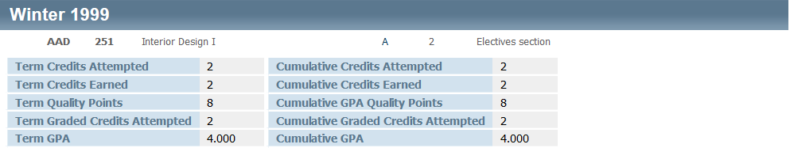

**Presenter: Term and Cumulative GPA Tracker**

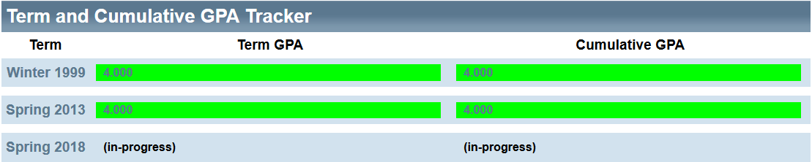

**Student – Advising Notes**

□ **Scroll to the bottom of the page to see advising notes.**

Notes/Questions: ___________________________________________________________________________________

__________________________________________________________________________________________________

**Student – Using the *What If* Tool**

□ **Try the *What* If tool** (as in “What if I changed my major to something else? What would my requirements look like?”

(**NOTE: Using the *What* If tool does *not* change your actual major.) * [See related presenter notes below.]**

Click on the left-hand side on *What If*.

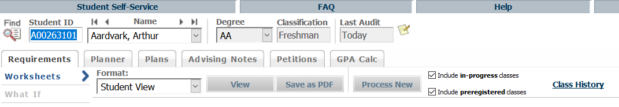

Select from the drop down box a major other than the one that you are currently declared into.

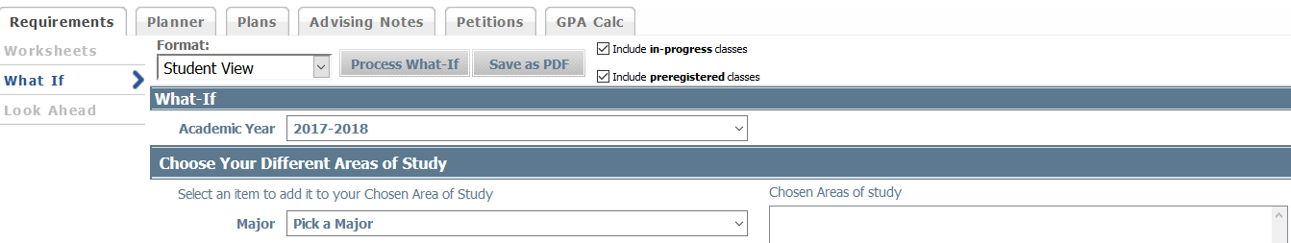

Click on *Process What-If* tab. View the results.



Notes/Questions: ___________________________________________________________________________________

__________________________________________________________________________________________________

***Can a “What If” scenario be printed?***

**Yes. It can be printed as a PDF file by selecting the “Save as PDF” tab.**

***Can a “What If” scenario be saved?***

**No, it cannot.**

**\* Presenter Notes: “What If”**

**Using the “What If” tool does not change your actual major. It runs a scenario only.**

**Student – Using the *Planner* Tool**

□ **Try the *Planner* tool. * [See related presenter note below.]**



Notes/Questions: ___________________________________________________________________________________

__________________________________________________________________________________________________

**The “@” sign can be used as a wildcard in the Planner:**

**Ex. 1: ART @ (when you know you’re going to take an ART-prefixed course but you haven’t decided which one)**

**Ex. 2: ART 2@ (when you know that the ART-prefixed class you’re going to take is a 200-level course, but you have decided on the exact 200-level class you want)**

**\* Presenter Note: Using @ Wildcard with Planner**

**Student – Using the *GPA Calc* Tools**

□ **Try the *GPA Calc* tools. * [See related presenter notes below.]**



Notes/Questions: ___________________________________________________________________________________

__________________________________________________________________________________________________

**\* Presenter Notes: GPA Tools**

**Term Calculator: Used to determine the cumulative undergraduate GPA based on grade projections for each course. This can be a helpful tool, for example, if a student is anticipating moving off probationary status or calculating GPA to see if they will qualify for the Aims Scholars Scholarship at term’s end.**

**Advice Calculator: Used to determine how many credits a student will need to complete with “A” and/or “B” grades in order to achieve the desired GPA.**

**Graduation Calculator: Doesn’t work.**

QUESTIONS FOR MY ADVISOR: ________________________________________________________________________

__________________________________________________________________________________________________

__________________________________________________________________________________________________

|  |  |  |
| --- | --- | --- |
|  |  |  |

**Presenter**

**Three sample records are accessible in Degree Works:**

1. **Billy Student: A00221510**

* Freshman
* Personal Interest Not Pursuing Aims Degree: Undeclared (no major)
* No GPA
* No holds
* No registered into classes
* Advising notes about major uncertainty and financial aid

1. **Artiana Aardvark: A00332218**

* Freshman
* Associate of General Studies: Exploring Career & Technical
* No GPA
* Returned mail hold
* Selective Service hold
* Not currently registered into classes

1. **Arthur Aardvark: A00263101**

* Freshman
* Associate of Arts: Liberal Arts
* No GPA
* Returned mail hold
* No Registration hold
* One “Not Applicable to Program” class (AAA 090)
* One transfer course
* Phone and transfer advising notes

**Presenter**

* *DegreeWorks* is ***not*** a tool to replace the academic advisor
* **Explain** what advising is [teaching, case management/relationship building, developmental model, partnership, etc.]
* **Explain** advantages of appointment vs. walk-in [time spent in appointment, focused meeting, advisor preparation]
* **Explain** advantage of preparing for appointment [efficient/focused use of time, advisor can gather resources]
* **Explain** advising services [initial career investigation, imparting culture of college, course selection, resource]
* *DegreeWorks* ***is* not** and ***does* not** replace your official transcript